UNNOFFICIAL TRANSLATION

AGENCY FOR THE PREVENTION OF CORRUPTION
Research and Analytics Division

PERCEPTION OF THE STUDENTS OF THE UNIVERSITY OF BELGRADE ON THE STATE OF CORRUPTION
AT THE UNIVERSITY
(Research Report)

Belgrade, December 2021

Contents
Introduction 3
- Introductory remarks 3
- Purpose of the research 3
- Some conceptual notes 4
- Realization and flow of the research 4
Data on the conducted research 6
- Sample structure 6
  - Structure of the sample according to the age of the male and female students surveyed 6
  - Structure of the sample according to gender of respondents 7
  - Structure of the sample according to the total monthly income of the households from which the surveyed male and female students come 8
  - The structure of the sample according to the method of study financing and the year of study 8
- Research results 9
  - Data on the perception of the presence of corruption and discrimination at the faculties, i.e. the University 9
  - Answers related to the respondents' personal experiences with corruption 14
  - Answers related to the reaction of the respondents to corruption 23
  - Perception of the role of the university and the faculties in dealing with corruption and combating it 29
CONCLUSION 46
Research results 46
- Data on the perception of the presence of corruption and discrimination at the faculties, i.e. the University 46
- Interviewees' personal experiences with corruption 47
- Answers related to the reaction of the respondents to corruption 48
- Perception of the role of the university and the faculties in dealing with corruption and combating it 50

Introduction
In addition to other competences established by the Law on Prevention of Corruption ("Official Gazette of RS", No. 35 of May 21, 2019, 88 of December 13, 2019, 11 of February 12 2021 - Authentic interpretation, 94 of September 27, 2021 and 14 of February 7, 2022, the Agency for the Prevention of Corruption (hereinafter: the Agency) is responsible for investigating the state of corruption, analyzing the risks of corruption and preparing reports with recommendations to eliminate the risks of corruption.
With regard to the aforementioned competence, based on the Annual Research and Analysis Plan of the Research and Analytics Division of the Agency for the Prevention of Corruption for 2021, the Agency conducted in the period from October to December 2021 the following research:
PERCEPTION OF THE STUDENTS OF THE UNIVERSITY OF BELGRADE ON THE STATE OF CORRUPTION AT THE UNIVERSITY
The aforementioned research was carried out through the Department for Research and Analytics as the direct implementer of the research, with the advisory support of the Institute of Social Sciences in Belgrade (hereinafter: Institute), with which the Agency concluded an agreement on scientific and technical cooperation in the field of researching and combating corruption.

  - Introductory remarks
Based on the hitherto practice of the Agency¹, as well as on the basis of hitherto investigations of corruption carried out in the Republic of Serbia, the field of education and, especially, the field of higher education has been observed to be one of the neuralgic points of corruption in the country. That fact was the main reason for making the decision to conduct the said research.
The research was conducted among students of six faculties of the University of Belgrade (Faculty of Law, Faculty of Philosophy, Faculty of Political Sciences, Faculty of Medicine, Faculty of Organizational Sciences and Faculty of Mathematics), taking into account the need to represent the faculties of all scientific fields at the University: fields of social and humanities science, fields of medical sciences, fields of technical and technological sciences and fields of natural and mathematical sciences.

  - Purpose of the research
The main goal of the research was to determine the degree of familiarity of the students of the University of Belgrade with the phenomenon of corruption in general, the degree and extent of their perception of its existence at the University, and concrete observations of students about potential courses and aspects of permanent action to prevent corruption in higher education.

- The Agency was established by the Law on the Agency for the Prevention of Corruption ("Official Gazette of RS", No. 97 of October 27, 2008, 53 of July 29, 2010, 66 of September 7, 2011 - CC, 67 of July 31, 2013 - CC , 112 of December 17, 2013 - Authentic Interpretation, 8 of January 26, 2015 - CC, 88 of December 13, 2019) and from its establishment on January 1, 2010 until August 31, 2020, operated under the name of Agency for Combating Corruption.

The further goal of the subject research is a comprehensive overview, based on the personal experiences of the surveyed students, of all aspects and forms of corruption that occur at the University of Belgrade.
In the long term, the research aims to look at the situation related to the risk factors of corruption at the University of Belgrade, so that the steps in the prevention of corruption not only at the University of Belgrade, but also at other higher education institutions in the Republic are properly directed towards reducing the existing risk factors, and towards strengthening the integrity of employees and students of the University as an important protective factor in the further prevention of corruption in higher education.
The research also aimed to specify the position and importance of the Agency in the process of preventing corruption in higher education as a segment of public life in Serbia.

  - Some conceptual notes
When compiling the notice about the intention to conduct the aforementioned research, as well as when compiling the questionnaire, the statutory definitions of certain terms used in the questionnaire were used, namely:
  - corruption - a relationship based on the abuse of office, i.e. social position or influence, in the public or private sector, in order to gain personal benefit or benefit for another (according to Article 2 of the Law on the Prevention of Corruption);
  - bribe - reward, gift or any other benefit that is directly or indirectly received or solicited for oneself or another person for the purpose of performing a service, undertaking an official act or refraining from an official act in order to obtain a benefit or eliminate damage from the person giving the bribe (according to articles 156 and 367² of the Criminal Code);
  - discrimination - any unjustified distinction or unequal treatment, i.e. omission (exclusion, limitation or priority), in relation to persons or groups as well as members of their families, or persons close to them, in an open or covert manner, based on race, skin color, ancestry, citizenship, national affiliation or ethnic origin, language, religious or political beliefs, sex, gender, gender identity, sexual orientation, gender characteristics, income level, property status, birth, genetic characteristics, health status, disability, marital and family status, convictions, age, appearance, membership in political, trade union and other organizations and other actual or assumed personal characteristics (according to Art. 2³ of the Law on Prohibition of Discrimination).

  - Realization and flow of the research
The research was carried out on the basis of the research plan⁴, which indicated the objectives of the research, the method of conducting the research, the stages and periods of the research, the analysis and the report on the conducted research.

- "Official Gazette of RS", no. 85 of October 6, 2005, 88 of October 14, 2005 - rev., 107 of December 2, 2005 - rev., 72 of September 3, 2009, 111 of December 29, 2009, 121 of December 24, 2012, 104 of 27 November 2013, 108 from October 10, 2014, 94 from November 24, 2016, 35 from May 21, 2019.
- "Official Gazette of RS", no. 22/2009 and 52/2021.
- The research plan was prepared by the Research and Analytics Department.

Based on the research plan, and taking into account the circumstances caused by the Covid-19 pandemic in the course of 2021, the research was carried out in the period from the beginning of October to the end of December 2021, in cooperation with the implementers (Agency for the Prevention of Corruption, Research and Analytics Division) with the administrations of the mentioned faculties, and with the advisory support of the Institute.
Before conducting the survey, letters were sent to the administrations of the aforementioned faculties with a proposal for cooperation, which were accepted by all faculties. After that, the Agency's letter about the intentions to conduct the research and use the results thereof was published on the websites and social media profiles of the targeted faculties.
The research was conducted in the period from October 19 to 29, 2021, by sending messages with a link to access the questionnaire to the email addresses of male and female students of said faculties, selected randomly. As the research was conducted at the end of October, during the enrollment period at the faculties, it was not possible to determine the final number of students who enrolled in the 2021/2022 academic year and data on the number of students enrolled until then was used instead. According to the data submitted to the Agency by the University and the observed faculties in the first half of October, the total number of students at the University is 72,457, and at the mentioned faculties 21,719. Bearing in mind the above, a total of 1052 students were determined as a sample, while a questionnaire with an access link was sent to the e-mail addresses of 3156 students. This number was determined on the basis of the received data on the number of male and female students by the faculties’ administration, in consultation with colleagues from the Institute of Social Sciences.
The survey was carried out using the method of an online questionnaire, in such a way that in cooperation with the administrations of the faculties of law, philosophy, mathematics and organizational sciences, questionnaires were sent to email addresses by random selection, while an online questionnaire was made available for students of the Faculty of Political Sciences and the Faculty of Medicine through the application that was placed on the websites of the targeted faculties, as well as on the faculty profiles on social networks, where a link to the application was published https://www.fpn.bg.ac.rs/48062 and https://www.facebook.com/175620802457215/posts/4755979327754650.
The questionnaire included three groups of questions: questions about the sociodemographic data of the respondents (age, gender, financial status, year of study), questions about the degree of familiarity with the problem, as well as questions about attitudes related to corruption. The questionnaire also included questions about the possible involvement of the students in corrupt activities. The survey was conducted anonymously and the protection of personal data of the respondents was ensured.

Data on the conducted research

Sample structure
The survey was conducted on a sample of 1,052 male and female students of all years of study at the mentioned faculties, born between 1985 and 2003. The sample was determined based on the data on the total number of active students at the observed faculties (21,719), which the researcher obtained from the administrations of the faculties, which ensured the representativeness of the sample.
  - Structure of the sample according to the age of the male and female students surveyed
The distribution of surveyed male and female students according to age was done in the research as follows:
  - 2003 – 1.6% of male and female students who filled out the questionnaire;
  - 2002 – 2.7% of male and female students who filled out the questionnaire;
  - 2001 – 16.6% of male and female students who filled out the questionnaire;
  - 2000 – 21.8% of male and female students who filled out the questionnaire;
  - 1999 – 26.0% of male and female students who filled out the questionnaire;
  - 1998 – 14.8% of male and female students who filled out the questionnaire;
  - 1997 - 7.5% of male and female students who filled out the questionnaire;
  - 1996 - 2.9% of male and female students who filled out the questionnaire;
  - 1995 - 2.7% of students who filled out the questionnaire, which is a total of 96.6% of all surveyed students;
  - 3.4% of respondents belong to other age groups - 1994 to 1985 (year of birth).

Graph 1

Age of surveyed students
030
26
21.8
16.6
14.8
7.5
3, 4
2.7
2.9
2.7
1.6

025

020

015

010

005

000
1985–94 1995 1996 1997 1998 1999 2000 2001 2002 2003

  - Structure of the sample according to gender of respondents
The distribution according to gender was carried out in the research as follows (Chart 2):
  - 64.5% of respondents are female;
  - 31.1% of respondents are male;
  - 4.4% of respondents did not want to state their gender.
Chart 2

Gender

Female Male
31%
4%
65%
I do not wish to answer

  - Structure of the sample according to the total monthly income of the households which the surveyed male and female students originate from
In relation to the total average monthly income of the households which the surveyed students originate from, the distribution is determined as follows:

Amount of income | Percentage
0.00 - 19,999.99 dinars | 5.5% of male and female students
20,000.00 - 39,999.99 dinars | 7.4% of male and female students
40,000.00 - 49,999.99 dinars | 7.0% of male and female students
50,000.00 - 59,999.99 dinars | 5.2% of male and female students
60,000.00 - 69,999.99 dinars | 5.7% of male and female students
70,000.00 - 79,999.99 dinars | 6.5% of male and female students
80,000.00 - 89,999.99 dinars | 7.6% of male and female students
90,000.00 - 99,999.99 dinars | 8.1% of male and female students
100,000.00 – 149,999.99 dinars | 10.9% of male and female students
150,000.00 dinars and more | 12.5% ​​of male and female students
Does not wish to answer the question | 23.5% of male and female students

  - The structure of the sample according to the method of study financing and the year of study
The questionnaire was filled out by:
  - 72.4% of students who are financed from the budget;
  - 27.6% of male and female students who are self-financing students.

Graph 3

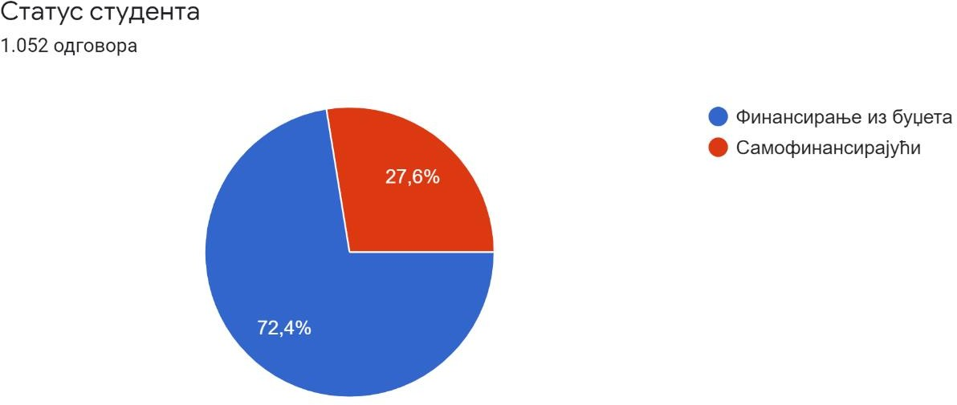

Thereby, the following distribution of results per years of study (Graph 4):
  - 2.6% of respondents - first-year students;

  - 27.0% of respondents - second-year students;
  - 22.1% of respondents - students in their third year of study;
  - 33.3% of respondents - fourth-year students;
  - 9.4% of respondents - fifth-year students;
  - 5.7% of respondents - female and male students of the sixth year of study.
Graph 4

Year of study

First Second Third Fourth Fifth Sixth
33%
9%
6%
3%
22%
27%

Research results
In the process of analyzing the collected data, the following groups of data were identified:
  - Data on the perception of the presence of corruption and discrimination at the faculties, i.e. the university
When asked what their opinion is about the presence of corruption at their faculty (measured by the intensity of corruption, ranging from 0 - corruption does not exist, to 9 - corruption is extremely pronounced), the surveyed male and female students gave answers that were grouped during the analysis of the results according to the intensity of the presence of corruption in three groups of answers⁵, namely:
  - corruption at the faculty of their respective studies is absent or present to a lesser extent (range of grades 0 to 3) - this is how a total of 46.2% of the surveyed students answered, which is close to one half of the respondents, while 14.2% of the respondents said that there was no corruption at all on their respective faculties;

- The stratification of groups of responses was determined by the research implementer during the process of analyzing the collected results.

  - corruption at their faculty is present, but not widespread (grade range 4 to 5) - this is what 15.7% of the surveyed students answered;
  - corruption at their faculty is present and is very widespread and pronounced (range of grades 6 to 9) - this grade was given by a total of 38.1% of the respondents, while the statement that corruption is extremely pronounced was expressed by 12.8% of the surveyed students .

Chart 5

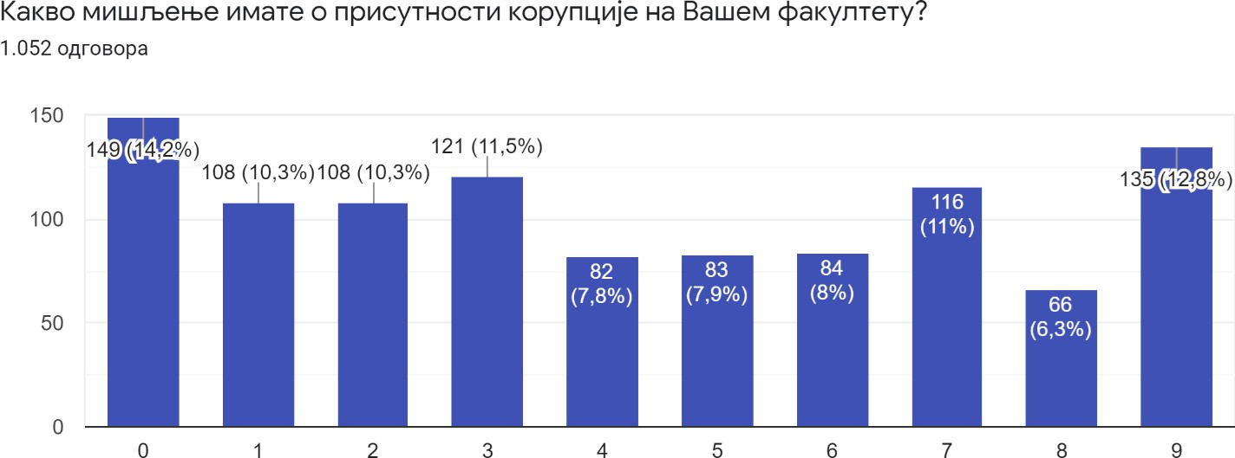

The situation is different when it comes to the perception of corruption at the University as a whole (Graph 6). When asked what their opinion is about the presence of corruption at the University of Belgrade, three groups of answers can be defined too (in the same given ranges of prevalence):
  - the first group includes the responses of students who believe that there is no corruption at the university at all or that it is present to a very small extent (range of grades 0 - 3). Such answers were given by a total of 15% of all respondents, while only 3.3% of respondents expressed the opinion that corruption at the university does not exist at all;
  - the second group consists of the answers of respondents who believe that there is corruption at the university, but that it is not present to a significant extent (range 4 - 5); there is a total of 21.9% of such answers;
  - A total of 63% of the surveyed students said that corruption at the university is widespread and very pronounced, while 19.7% said it was extremely pronounced.

Graph 6

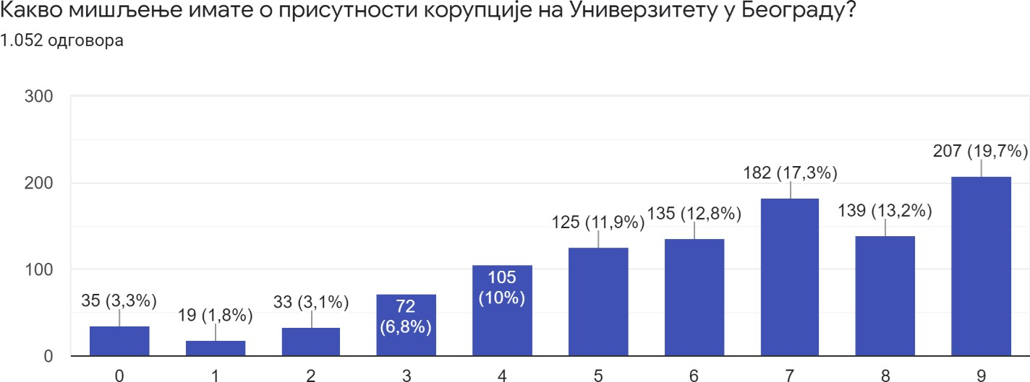

Male and female students of the observed faculties perceived the existence of discrimination at their faculties as shown in Graph 7. When asked whether they believe that there is discrimination at their faculty when taking exams, the respondents answered as follows:
  - 44% of those surveyed answered that they believe that discrimination exists;
  - 31.8% declared that they do not know whether discrimination exists;
  - 20.5% denied the existence of discrimination in their answers;
  - 3.7% did not want to answer that question.
Chart 7

Do you think that there is discrimination at your faculty when taking exams?

Yes No
20%
32%
4%
44%
I do not know
I do not wish to answer

A total of 231 answers were given to the question “If the answer to the previous question is 'Yes', describe on what basis the discrimination is carried out?” Given the fact that one answer contains several grounds of discrimination, a total of 358 answers were given about the grounds of discrimination. In the process of analyzing the collected data, the research implementers determined 13 types of answers on the grounds of discrimination when taking the exam:
  - gender and sexual orientation - 95;
  - origin (belonging to an influential family); social influence and power; social status, property status - 61;
  - nepotism; cronyism; acquaintance with the examiner - 39;
  - bribery; “deal”/arrangement with the professor; regular private consultations – 26;
  - nationality; religion; race – 19;
  - personal preference and discretion of the examiner - 19;
  - grade average and duration of studies – 19;
  - physical appearance and attire - 18;
  - political opinions; political connection; partisan affiliation - 12⁶;
  - native origin (positively discriminated Belgraders) – 7;
  - membership in the student parliament (positive discrimination) – 6;
  - vaccination status – 5;
  - unspecified answer - various grounds; all grounds; any ground – 37⁷.
Here are some more interesting answers about discrimination:
- Currently on the grounds of vaccination status.
- Family relations, primarily, “buying” exams through “regular consultations” that the lecturers hold privately, outside the teaching premises.
- At the personal and ideological discretion of the examiner.
- Gender, nationality, property, power.
- With some professors, the outcome of the exam depends on whether you are fortunate enough that they like you. This does not refer to one’s manner of presentation, but exclusively to such professors’ personal criteria, such as which football team you support, your name, whether you have the same opinion as them on topics unrelated to the subject of the exam…
- Professors often insult students, especially female students. In such cases, if they don't like the region/city they come from for example, they will flunk you if it’s an oral exam. In my case, the professor drew my grade from a lottery by spinning pieces of paper with the grades written on them and told me to pick one. If a student cannot switch examiners, if he/she is a member of the student parliament or he/she has some kind of arrangement with the professor, then there are no problems at all.
- The “chosen ones”, such as members of the student parliament, athletes or children of influential people often pass exams without others even knowing when they took them.

- Affiliation with the ruling party was mentioned by two respondents as grounds for positive discrimination.
- Two respondents cited “rooting for the same football team as the examiner” as grounds for positive discrimination of students.

  - Of course, it does not exist in the case of each and every professor, but it does exist for some professors based on gender, appearance, the football club they root for, religion...
  - Children of politicians or famous lawyers and the like pass exams merely on the grounds of their first and last name. Discrimination by appearance, gender...
  - By place of birth, residents of Belgrade are positively discriminated against.
  - Bribery, of course.
  - Kinship, hometown or godfather connections, sexual liaisons... etc, string-pulling for taking exams and advancing in one’s academic career (e.g. who will be selected as an assistant).
  - Children of parents affiliated with the ruling party get unmerited favors in passing examinations.
  - Certain politically active professors are more lenient through questions, suggestions for answers during exams towards students who have shown interest in the political ideology of the given professor during their studies.
  - Students that have a job, students without a permanent place of residence in Belgrade and students who study online are routinely discriminated against.
  - Discrimination against persons with disabilities and on the basis of origin.
  - Discrimination of "daddy's boys” and mommy's girls.” No restrictions for them whatsoever.
  - On the grounds of corruption.
  - From what I've heard, female colleagues who don't agree to having sex fare the worst.
  - The other day, a colleague told me that her professor told her that she doesn't have a city mentality since she's not from Belgrade.
  - Foreign students pay enormous tuition and get better treatment, they don't have oral exams, they are privileged; discrimination on the grounds of sexual orientation and nationality (foreigners enjoy favors even though they have not mastered Serbian well, professors allow them to answer in English), at the Faculty of Medicine female students suffer sexist insults without any sanctions from teachers; if you don't have someone to pulls strings for you, you better not study medicine.
  - Students who pay for good grades pass, and professors then flunk other students in order to meet their quotas for failing students.
  - Some doctors’ children (not all, of course) have special appointments for private exams, which they complete in 10 minutes or they take exams with other students with easier questions that they know in advance. The children of the “family friends” of professors take “consultations” with them right before the exam itself. Female students who had intimate relations with assistants do not have to prepare for the practical exam and enjoy special favors for the oral exam, because “it’s been arranged with the assistant.”
  - There are professors who accept bribes for passing the exam at almost a fixed rate, which makes it possible to pass the exam without any effort, which ultimately results in poorly trained staff in healthcare.
  - Based on the fact that someone's parent is a politician from the area of medicine, those persons pass exams without answering orally and take the exam without the presence of other students.
  - You need to be well dressed, to be somebody’s protégé, you should not be a member of the LGBT population, based on who your parents are, whether girls sleep with professors for grades or not.
- Acquaintances, nepotism, influential families, political connections.
- The son of a professor of my faculty took the exam a day before everyone else on the list.
- At the Faculty of Medicine, it varies from department to department. In particular, discrimination is present in the department of anatomy, where, for example, those who pay for a certain school of anatomy, a disk or even a professor, fare better.
- Many professors (lecturers and assistants) are in a conflict of interest, because they teach private lessons; students who attend those lessons do better because they have paid the professor (for a job for which the professor already receives a salary from the state!).
- The criteria are not the same for students who come without “preparation and private lessons” (with professors/assistants), for those who come because they are “somebody's” children (mostly professors) and for others. Example - answering to three questions that are known beforehand, regardless of which three questions are drawn.
- Some female students had romantic relationships with assistants and teaching assistants and took exams knowing the assignments in advance, as well as the fact that these same assistants revised their papers.

  - Answers related to the respondents' personal experiences with corruption
When asked if a third party has ever suggested to them to broker some kind of bribe giving in order to pass an exam, obtain a diploma or achieve some other benefits related to studying (Chart 8):
  - 78.7% of respondents answered that they had no such experience;
  - 14.2% of respondents answered that they had such an experience;
  - 7.1% of respondents did not want to answer the question.
Graph 8

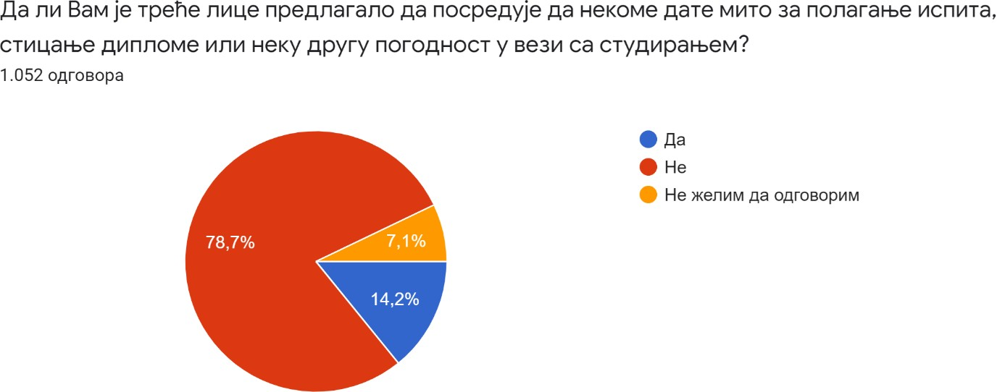

Some short descriptions of the cases given by the respondents when answering "Yes" are interesting.

  - An unknown person told me that I should pay a certain amount of money per year of study to a certain individual, and when the studies come to an end, I will know in advance that I will for sure have a degree “arranged.”
  - A common phenomenon, you know exactly who to turn to.
  - Once it was an older student (4th year of undergraduate studies) who told me about the possibility of paying for passing the exam, as well as for the diploma - depending on the course, it would be between 50 euros and 200 euros per exam, and another friend knows a guy to pay money to in order to get the degree.
  - For example, for one exam at our faculty, people massively suggest that if there is a possibility, we should pay the professor to let us pass it, because it is practically "impossible" to pass.
  - After most of the students had failed the exam in one term, an acquaintance said that he would “fix it” it in the next term and if I wanted, he could fix it for me as well (for a fee). In the next term, a colleague was not on the list of students who took the exam, but he did pass it and the grade was entered on the e-student portal
  - For a fee, I was offered to take a person's place to take an exam that the person in question had not been able to pass for years. I refused.
  - The person proposed a “business cooperation” of one of the members of the teaching staff with the parents of students.
  - I was offered a state faculty diploma for 6,000 euros.
  - An assistant “discreetly” let me know that I should “prepare well” for the exam, i.e. bring 500 euros, and he will “fix it” with the professor.
  - The head registrar made a proposal to me.
  - During the exam, the professor told me that I didn't have enough knowledge for a passing grade, while commenting that I should find someone to help me master the curriculum or find some other way to pass the exam.
  - During the practical exercises in anatomy, the assistant proposed private lessons with her and the professor, with the promise that we would surely pass and the comment “Well, how did you think you could graduate from this faculty?”
  - After I passed the exam, I found out that one could “buy” exams from certain professors at the Faculty of Medicine through a technical person (cleaning lady).
  - I know exactly the tariff for each particular exam and who one needs to pay, and yet everyone remains silent about it, because if someone finds out that you are a “snitch” you will not graduate from the faculty.
  - I think the price for passing an exam is well-known. In the course of this year there were a lot of cases and everyone is aware of that. After the anatomy exam (which I failed), the professor gave me a business card with his phone number, advising me to contact him if I wanted to do some serious work and pass the exam.
  - It was an exam in the first year of medicine, specifically anatomy, which I had not yet passed until that moment, and the October exam term was approaching. I received proposals to pay for the exam, either from other students, acquaintances, or from the professor herself, whom I eventually pulled aside with the words: "Do you want to make a little arrangement about the grade?”
  - The tariffs are known and the people who have paid them - they offer their colleagues to "fix" the exams for them too.

•

•
•
It has become a common and normal thing that there are more “bought” exams than truly passed ones, and that only the ones who didn't have the opportunity to do it and a couple of “fools” actually study, because they think they should.
It happens on regular basis.
“Preparation lessons”
and
“consultations”
that
are
paid for
either
with
the
assistants
or professors in the cabinet or at their home.
When asked whether during their studies, any of the faculty employees (teaching or non-teaching staff) asked them for a bribe, the surveyed students gave the following answers (Chart 9):
  - 87.9% answered that they had not personally had such an experience;
  - 7.8% (82 respondents) answered that they had the opportunity to meet such employees;
  - 4.3% did not want to answer.
Chart 9

During your studies, did any of the employees at the faculty
(Teaching or non-teaching staff) asked you for a bribe

No
4%
8%
88%
Yes
I do not wish to answer

When asked what kind of bribe was solicited from them, 69 of the 82 respondents confirmed that they had been asked for a bribe. The following answers were received (Chart 10):
  - 75% of those who responded indicated that they had been asked for money;
  - 13.2% indicated a gift as a form of bribery;
  - 11.8% cited some service as a form of bribery.

Chart 10

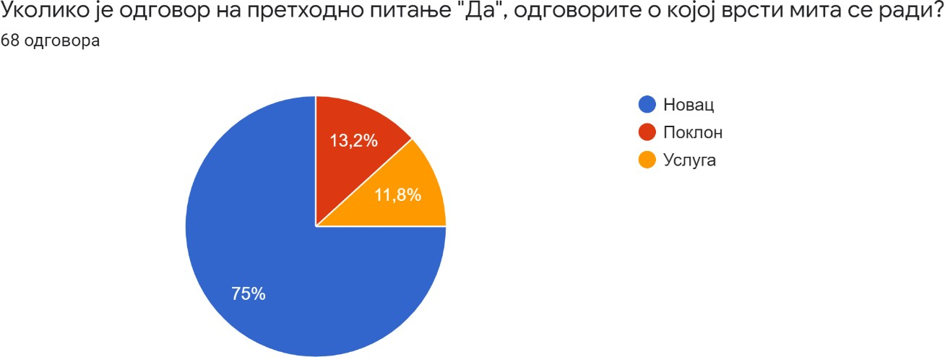

To the question “If the answer to the previous question is a 'gift' or a 'service', describe what kind of gift or service it is?” 68 descriptive answers were given. Some of them included the following:
  - Indecent proposal.
  - Money in a certain amount to make sure that the exam is passed.
  - The professor asked us to go for a drink.
  - Administrative and legal relief was requested in the procedures of legalization of property owned by a member of the teaching staff.
  - The gentleman from the student department told me that nothing can be bought for a simple “thank you” and that I could bring him a whiskey when I'm already bothering him so much.
  - Drinks, chocolates, coffee, pen, tickets for the Bajaga concert.
  - Whiskey.
  - Service of a sexual nature.
  - To schedule a medical examination with my father.
  - Perfume.
  - It was discreet but very clear - there is a way to solve the problem but it costs money.
  - “You, son, could at least bring a box of candy for this service?” (when issuing a certificate).
  - 500 euros.
  - Going to lunch.
  - I was expected to bring something to the consultation, and since I didn't, they weren't held for me.
  - The teaching staff is no stranger to asking for the payment of a utilities bill so that the student can have an insight into the preliminary exam and the like.
  - Is an invitation to have sex a favor or a gift?

The following are the shares of different answers to the question about the personal involvement of the students themselves in corruption at the university by offering bribes (Graph 11):
  - 96.2% of respondents answered that they did not offer bribes to faculty employees;
  - 1% of respondents answered that they had offered bribes to university employees in order to obtain some benefits related to their studies;
  - 2.8% of respondents did not wish to answer that question.
Graph 11

Did you offer a bribe to an employee at the university during your studies?

Yes No
1%
3%
96%
I do not wish to answer

Regarding the type of bribe that the respondents offered to employees at the faculty, 11 answers were offered (Chart 12):
  - 6 mentioned money as a form of bribery;
  - 4 mentioned a gift as a form of bribery;
  - One student mentioned a service as a form of bribery.

Chart 12

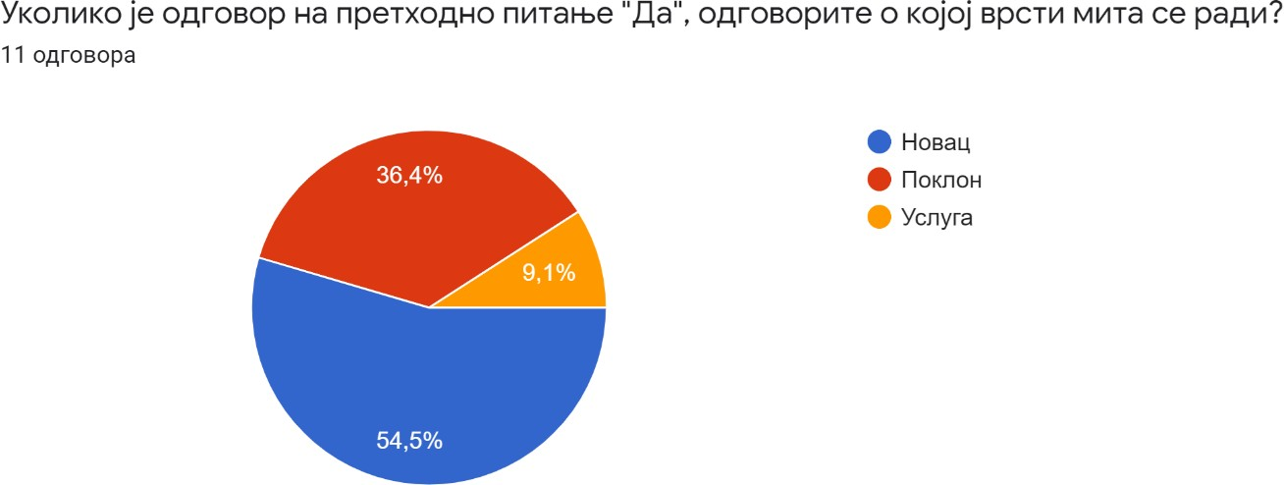

When asked if they had bribed any employee at the faculty during their studies, the respondents answered as follows (Chart 13):
  - 96.4% of the respondents said that they did not bribe employees at the faculty;
  - 2% of respondents confirmed having bribed employees at the faculty;
  - 1.6% of respondents did not want to answer the question.
Graph 13

Did you bribe an employee at the university during your studies?

2%2%
96%

Yes No
I don't want to make a statement

Out of 1,052 respondents, 21 respondents, or 2%, declared that they had given bribes to university employees. Twenty of them answered the question about what type of bribe it was (Chart 14), whereby ten of them indicated money as the type of bribe, four answered that they gave a gift, while one respondent answered that they gave (provided) a service.

Chart 14

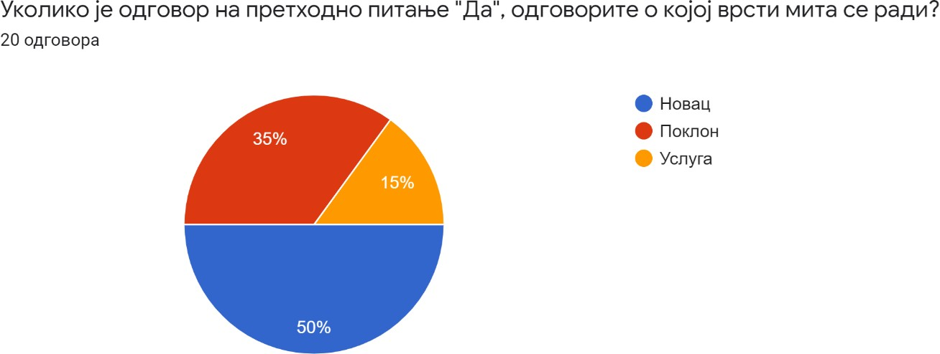

46 respondents answered the question as to what service/convenience they had given a bribe for, if they did bribe an employee at the faculty during their studies, with the possibility of giving multiple answers, (Graph 15):
- 22 respondents did not want to answer what kind of convenience or service it was;
- 14 respondents answered that they had given a bribe to pass the exam;
- 11 respondents stated "other" as the reason for bribery.
None of the respondents mentioned enrolling in faculty or obtaining a diploma as a reason for bribery.

Chart 15

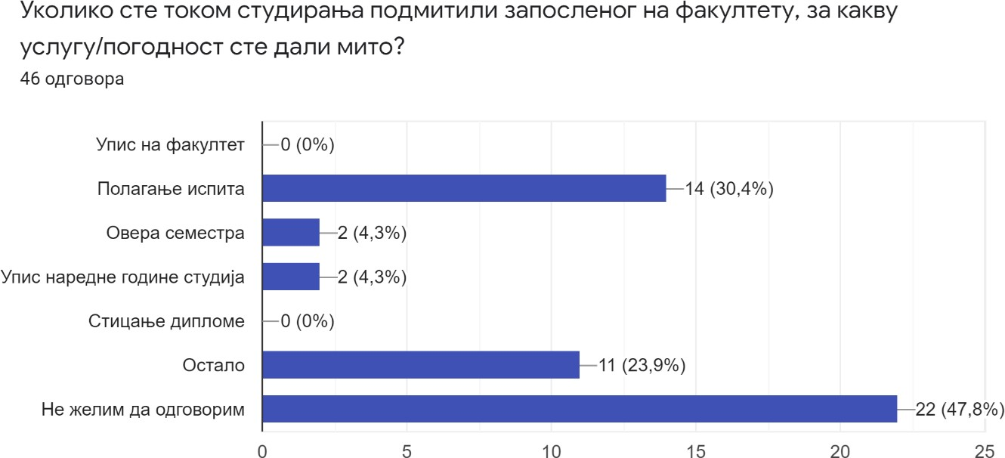

To the question of whether the respondents had heard of someone who, using a bribe, passed an exam, obtained a diploma or obtained a benefit at any faculty of the University of Belgrade, all of the respondents from the sample group answered and a total of 1052 answers were given. The answers were distributed as follows (Chart 16):

  - 76.4% of the total respondents answered that they had heard of a student who has passed an exam, obtained a diploma or obtained a benefit by resorting to bribery;
  - 21.3% of the total respondents answered that they did not hear of such students;
  - 2.3% of the total respondents did not want to answer the above question.
Chart 16

Have you heard of someone who, using a bribe, has passed an exam, obtained a diploma or some other advantage at any faculty of the University of Belgrade?

Yes
21%
77%
2% No
I do not wish to answer

When asked if they personally know a student who has passed an exam at a faculty of the University of Belgrade in some other illicit way (by copying, using earpieces, by having another person take the exam for them, etc.), the respondents answered as follows (Chart 17):
  - 83.5% of the total respondents answered that they know such persons;
  - 14.1% of the total respondents answered that they do not know such persons;
  - 2.5% of respondents did not wish to answer the said question.

Graph 17

Do you know someone who has passed an exam at one of the faculties of the University of Belgrade in some other illicit way?

Yes No
3%
14%
83%
I do not wish to answer

As for the question of whether the respondents know that a diploma can be purchased at their faculty, to which all 1052 respondents answered, the answers were distributed as follows (Chart 18):
  - 76.9% of respondents answered that they have no such information;
  - 14.9% of respondents answered that they have such information;
  - 8.2% did not want to answer the question.
Graph 18

Do you know that it is possible to buy a diploma at your faculty?

Yes No
15%
8%
77%
I do not wish to answer

Answers to the question of whether they know of any such case are generally in line with the pattern of previous answers, whereby a total of 218 answers were given (Chart 19):
  - 60.1% of the answers given were negative;
  - 22% of the answers given were positive;
  - 17.9% of respondents did not wish to answer the question.
Graph 19

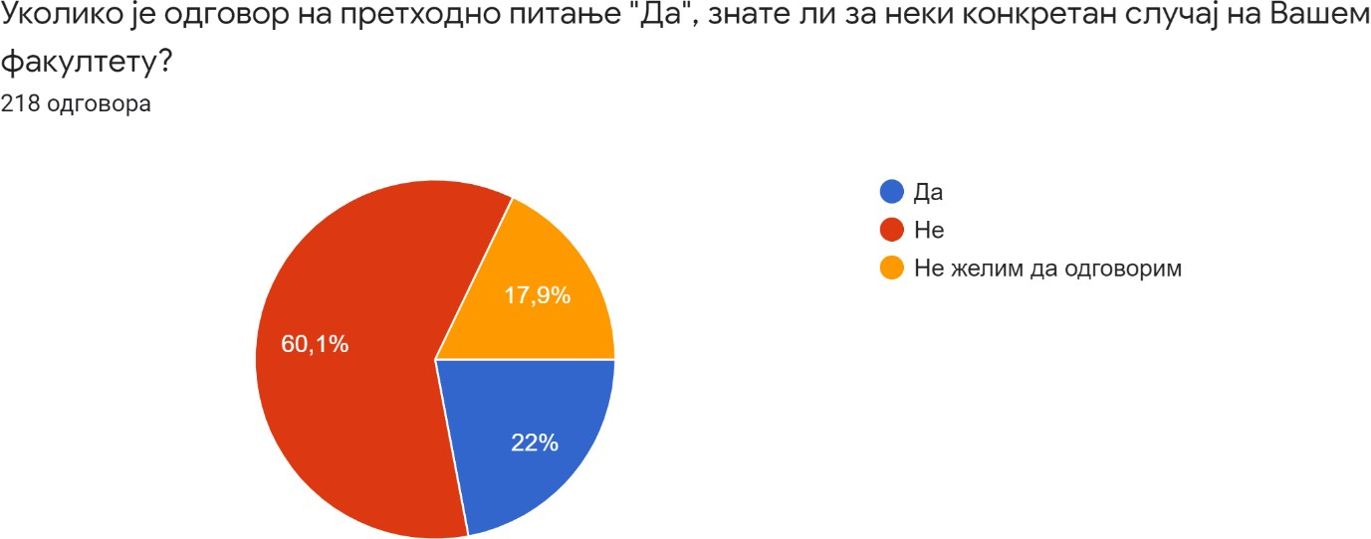

  - Answers related to the reaction of the respondents to corruption
The questionnaire also contained questions concerning the reaction of students from the sample to corrupt practices at their faculties, i.e. whether they had already reported corruption at their faculty/university, what experiences they had in connection with reporting corruption, and whether they would report corruption at their faculty/university in the future.
All the respondents answered the question as to whether they had reported corrupt practices at their faculty or at the university. The answers are distributed as follows (Chart 20):
- 95.6% (1006) answered that they did not report corruption at the faculty or university;
- Only 0.8% (nine respondents) from the sample answered that they have reported corruption at the faculty or university;
- 3.6% of respondents did not want to answer the question.

Chart 20

Have you ever reported corrupt behavior at your faculty or university?

YesNo
1%
3%
96%
I do not wish to answer

Respondents who had reported corruption indicated to whom they reported corrupt behavior.
  - The professor.
  - The head of the department.
  - To the dean and the professors.
  - I tried to point out the professor's invalid way of working.
  - Since there were quite a few cases, on several occasions I reported cases of extortion of private lessons to the professors from the department who led my practical classes and to the head of the department, while once we also reported bribe offering for an exam to the dean's office.
  - To certain professors, but it was not accepted.
  - I don't even know who to report it to.
  - To a professor on the first year.
  - I went to the Rectorate, wrote emails to the university several times and everything was covered up.
One answer contradicted the others, but it is significant because it indicates insufficient awareness among the students as to who they can report corruption to at the university (The answer is no, but I have a question for you - Who exactly should we report such practices to? These people are judge, jury and executioner!):
To the question “If you have reported corrupt behavior at your faculty or university, what is the outcome of the report?” 43 answers were given (Chart 21). It can be assumed that an answer was also given by a number of those who opted for the option “I do not wish to answer.” Of that number:
    - 55.8% answered that they are not aware of the outcome of the procedure;
    - 23.3% did not want to answer the question;

    - 18.6% answered that no procedure whatsoever had been initiated;
    - Only 2.3% answered that the procedure has been completed.
Chart 21

If you have reported corrupt behavior at your faculty or university, what was the outcome of the report?

The procedure has not been started
23%
19%
2%
0%
56%
The procedure is in progress
The procedure has ended
I don't know
I do not wish to answer

49 answers were given to the question of whether they suffered consequences as “whistleblowers” after reporting corrupt activities at their faculty or university. The answers are distributed as follows (Chart 22):
  - 44.9% of the respondents did not want to answer the question;
  - 38.8% of the respondents answered that it had no consequences;
  - 16.3% of the respondents answered that they suffered consequences.

Chart 22

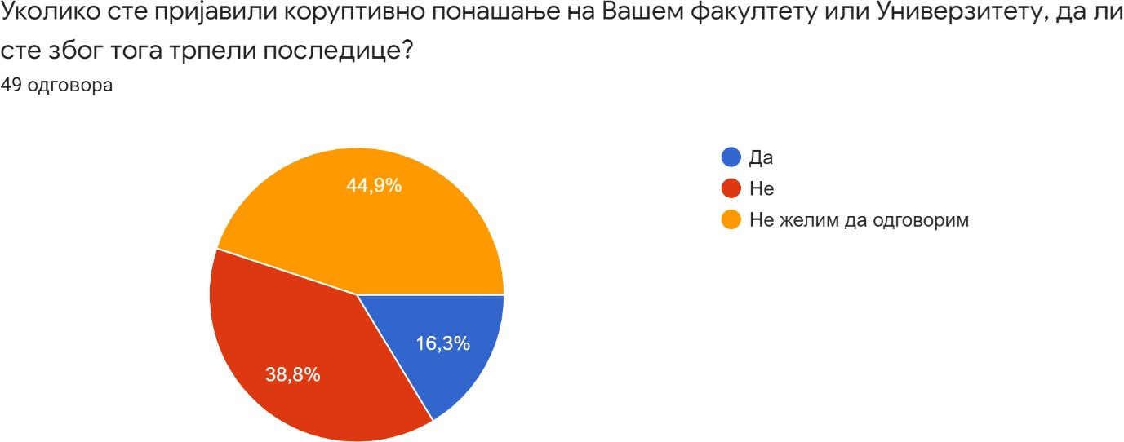

To the question “If the answer to the previous question is 'Yes', what kind of consequences did you suffer?” the following answers were given:
  - I had problems with passing a certain exam that came after my report.
  - The unfair behavior of the mentioned professors and the psychological torture that is difficult to recount, but certainly something that those people practice on regular basis.
  - Mental bullying.
  - Threats.
The distribution of responses to the question of whether students would report corrupt behavior at their faculty in the future was as follows: A total of 1052 answers were given (Chart 23), of which:
  - 55.7% of the respondents answered that they would report future corrupt behavior;
  - 23.2% answered that they would not report such behavior in the future either;
  - 21.1% did not wish to answer the question.
Chart 23

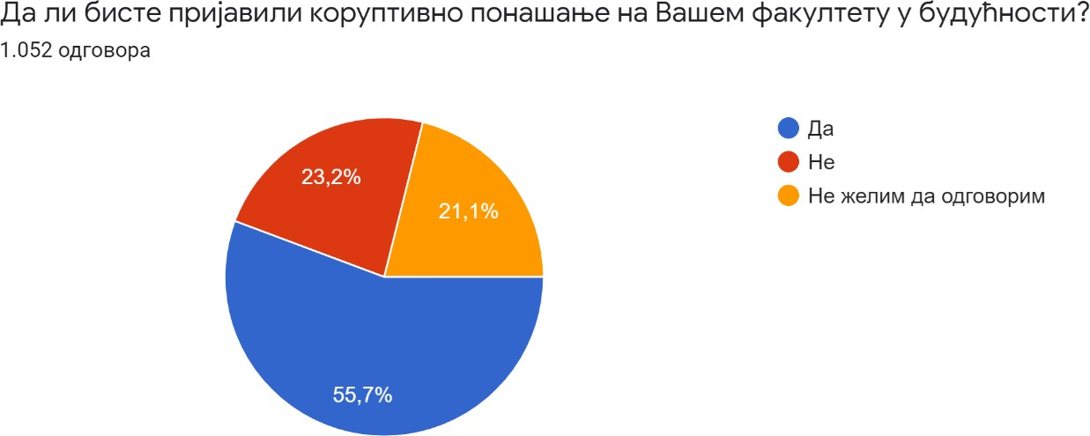

To the question to whom they would submit a report for corrupt behavior if they decided to take such a step, a total of 620 students answered, that is, 58.9% of the entire sample. (Graph 24).
Their responses⁸ were distributed as follows:
  - 56.3% (349 responses) of those who answered the above question would submit a report to the Agency for the Prevention of Corruption;
  - 42.9% (266 responses) would report corrupt behavior to the faculty;
  - 41.1% (255 responses) would report corrupt behavior to the University;
  - 24.0% (149 responses) would report corrupt behavior the media;
  - 20.0% (124 responses) would file a complaint with the police;
  - 19.2% (119 responses) would report corrupt behavior to the superiors of the person engaging in corrupt activities;
  - 16.9% (105 responses) would report corrupt behavior to the public prosecutor's office;
  - 16.9% (105 responses) do not know whom to report corrupt behavior to;
  - 11.8% (73 responses) would report corrupt behavior to a non-governmental organization;
  - 3.9% (24 responses) would report corrupt behavior to someone else outside of the options offered ;
  - 1.8% (11 responses) did not want to answer the question.
Chart 24

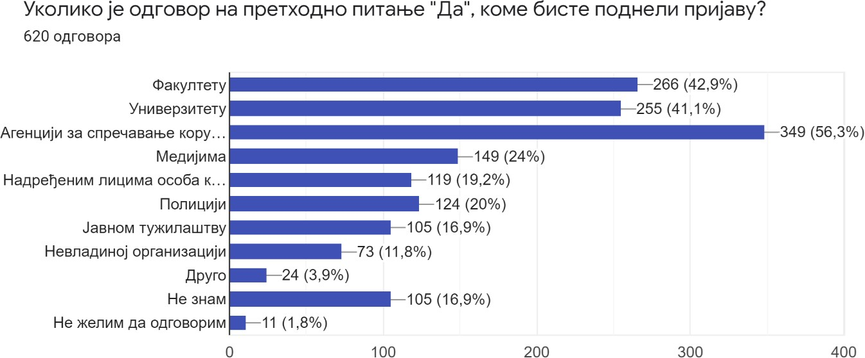

The following answers were given to the question of which body at their respective faculty is competent for handling corruption complaints, with the possibility of giving multiple answers at the same time (Chart 25):
  - 76.1% (801 responses) answered that they do not know;
  - 19.2% (202 answers) answered that the dean of the faculty is in charge;
  - 12.4% (130 responses) answered that the faculty council is competent;

- For answers to these questions in the questionnaire, there is an option to give multiple answers at the same time.

  - 9.4% (99 responses) answered that the academic council is competent;
  - 6.8% (72 responses) answered that the student parliament is competent;
  - 6.3% (66 responses) answered that the faculty secretary is competent;
  - 0.9% (9 responses) answered that someone else outside of the options offered is competent.
Chart 25

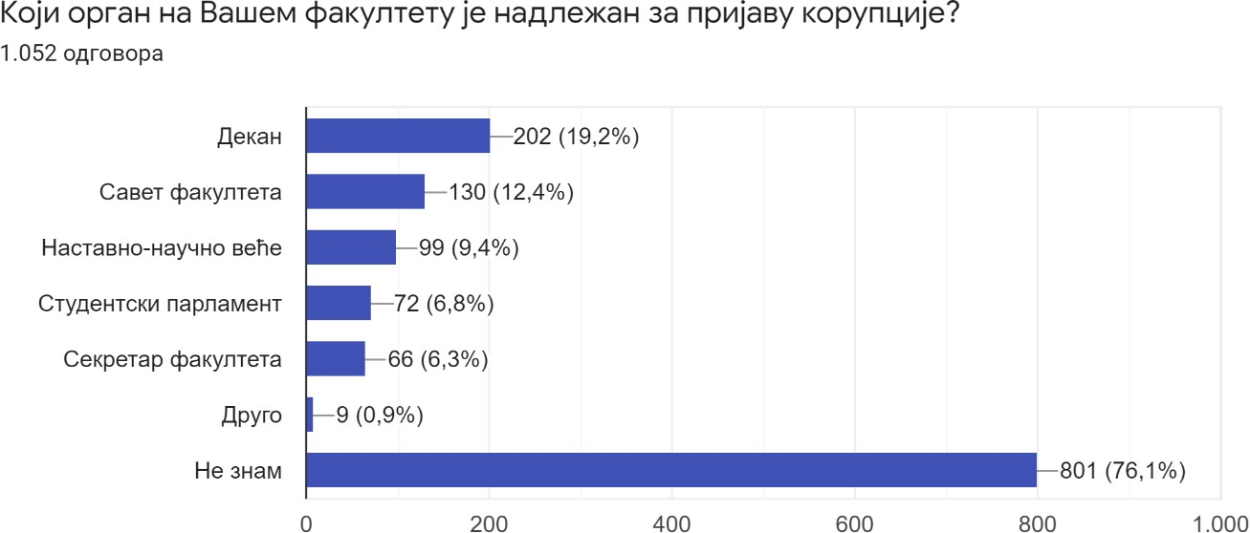

When asked what methods should be used to combat corruption at the faculties, i.e. the University, with the possibility of giving several options at the same time, the answers were distributed as follows (Graph 26):
  - 61.1% (643 responses) of the total respondents advocated for greater public awareness on specific cases of corruption;
  - 60.7% (639 responses) were in favor of stricter application of prescribed penalties;
  - 51.2% (539 responses) were in favor of raising awareness about the harm of corruption;
  - 40.7% (428 responses) were in favor of imposing stricter penalties;
  - 6.7% (70 responses) did not know which method they could resort to.

Chart 26

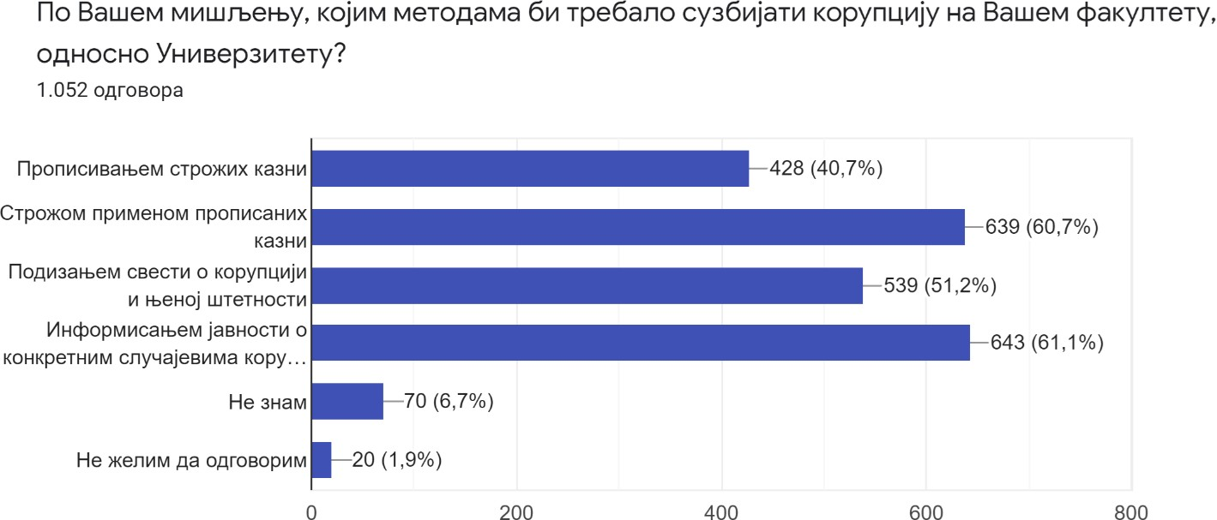

  - Perception of the role of the University and the faculties in addressing and combating corruption
This group of questions includes those about students' awareness of the existence of codes of conduct at their respective faculties, i.e. about knowledge of the content of such codes, as well as a set of questions related to the degree of trust of students in the authorities of their respective faculties, i.e. in the authorities of the university relative to addressing corruption and the mechanisms of combating corruption.
Regarding the issue related to the awareness of students about the existence of a code of conduct, a code of ethics or a similar document that regulates the behavior of teachers and students of the faculty in teaching activities and in the process of evaluating students, the following distribution of responses was achieved (Graph 27):
  - 61.1% of the surveyed male and female students (almost 2/3 of the sample) answered that they were aware of the fact that at their respective faculty there is a code of conduct, a code of ethics or another similar document governing the conduct of teachers and students of the faculty in their teaching activities and in the student evaluation process;
  - 33.9% of surveyed male and female students (1/3 of the sample) answered that they did not know about the existence of such an document;
  - 4.9% of surveyed male and female students denied that there is such a document at their respective faculty.

Graph 27

Does your faculty have a code of conduct for teachers and students, a code of ethics or another similar document?

Yes No
5%
34%
61%
I do not know

Regarding the question of whether the surveyed male and female students are familiar with the content of the code of ethics or another similar document that regulates the rules of behavior of teachers and students of the faculty in teaching activities and in the process of evaluating students, a total of 668 answers were given (which is 63.5%, i.e. almost 2/3 of the total sample). These answers were distributed as follows (Chart 28):
  - 55.7% of male and female students who answered stated that they were familiar with the content of such a document;
  - 42.7% of male and female students who answered declared that they were not familiar with the content of such a document;
  - 1.6% of male and female students declared that they do not wish to answer the said question.

Chart 28

If the answer to the previous question is "Yes", are you familiar with the content of that document?

Yes
43%
56%
1% No
I do not wish to answer

The degree of trust of the surveyed students in the authorities of the university, i.e., the authorities of their respective faculties based on the following questions: “What is the degree of trust in the authorities of your faculty/university in terms of addressing and combating corruption?” was rated by all 1052 respondents from the sample. The respondents rated their trust in the university's authorities, i.e. their respective faculty, with grades from 0 to 9, and their answers were distributed as follows (graphs 29a - 29k):
A) The answers of the surveyed students about trust in the rector⁹ can be grouped into three groups of 10 answers (first group: no or very little trust - grades 0 to 3; second group: partial or moderate trust - grades 4 and 5; third group: high degree of or complete trust - grades 6 to 9), and the percentages are the following:
  - 13.1% of respondents answered that they have no confidence at all in the rector of the university in addressing corruption and his activities to combat corruption at the university;
  - the next 6.2% of respondents rated their trust in the rector with the grade 1 - their trust in the rector’s actions in relation to combating corruption at the university is minimal;
  - 7.9% of the respondents rated their trust in the actions of the rector of the university in combating corruption at the university with the grade 2;
  - 9.5% of the surveyed students rated the activities of the rector of the university in combating corruption with the grade 3.
Thus, 36.7% of the respondents have no or very little confidence in the actions of the university rector regarding the combating corruption at the university;

- As of October 1, 2021, the new rector of the University of Belgrade took office.
- The stratification of groups of responses was determined by the research implementer during the process of analyzing the collected results.

  - 12.8% of the respondents rated their trust in the rector's work in combating corruption at the University with the grade 4;
  - 18.6% of the respondents rated their confidence in the rector's work in combating corruption at the University with the grade 5.
Thus, 31.4% of those surveyed have partial or moderate confidence in the actions of the rector in connection with combating corruption at the University.
A total of 31.9% of those surveyed have a lot of trust or complete trust in the rector's work in combating corruption at the University, with 7% of the respondents declaring that they have complete trust in the rector's actions (Graph 29a).
The ratio between the three groups of answers is almost evenly distributed on approximately 1/3 of the respondents, with the percentage of respondents who have no confidence at all or little confidence in the rector's activities prevailing by about 5% compared to the other two groups.
However, one could observe the ratio of respondents who have no confidence at all (13.1%) to the respondents who have full confidence (7%).

Chart 29a

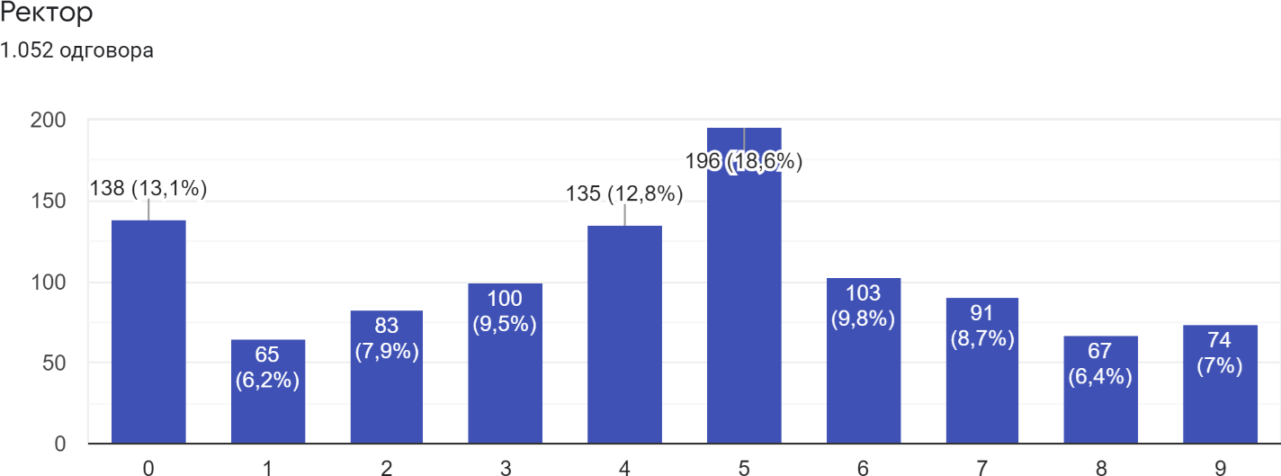

B) The answers of surveyed students about trust in the rectors' board were distributed in approximately similar percentages in relation to the answers related to trust in the rector of the university proper (Graph 29b), which is understandable considering the fact that the rectors' board is managed by the rector of the university proper.
  - 38.3% of the respondents declared that they have no or very little trust in the actions of the rectors' board, while 12.7% of the total respondents have no confidence whatsoever in the actions of the rectors' board;
  - 31.4% of those surveyed have partial or moderate trust in the action of the rector's board in connection with combating corruption at the university (the percentage of these answers matches the percentage of answers given about trust in the rector);

  - 31.3% of respondents declared that they have a lot of trust or complete trust in the work of the rectors' board, while 5.6% of respondents declared that they have complete trust in the activities of the rectors' board.

Chart 29b

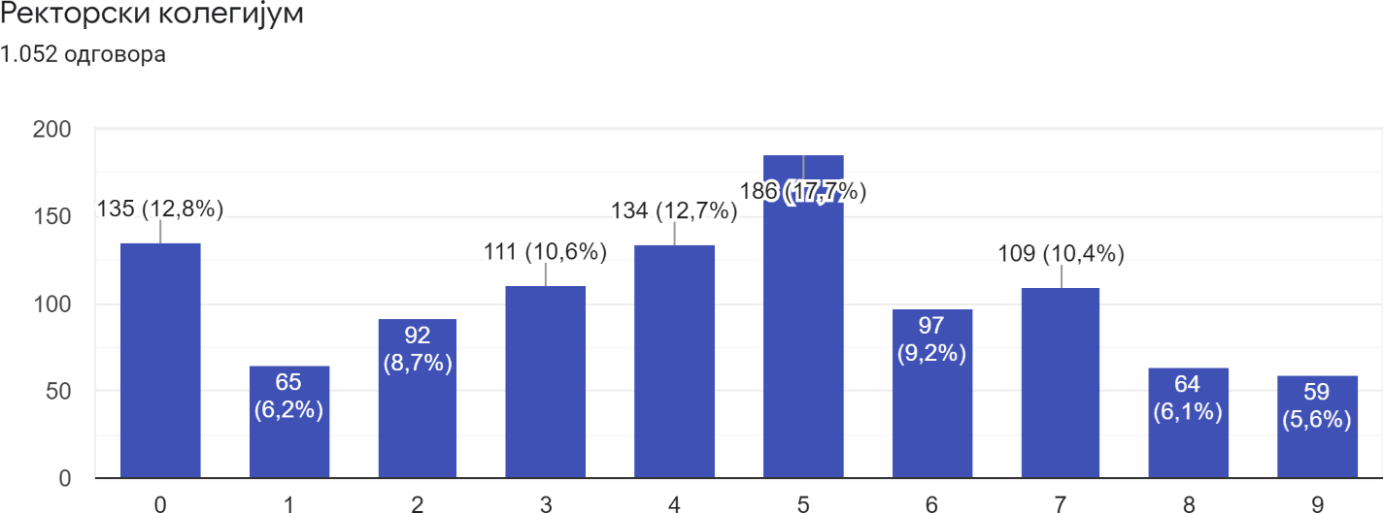

C) The activities of the university council (Chart 29c) were graded as follows:
  - 38.8% of the respondents stated that they have little or no confidence in the activities of the university council regarding combating corruption at the university, while 14.1% of the respondents stated that they have no confidence at all in the work of the university council;
  - 29.8% of those surveyed declared that they have partial or moderate confidence in the work of this body;
  - 31.4% of respondents declared that they have a lot of trust or complete trust in the work of the said body, while 6.2% of respondents declared that they have complete trust in the work of the university council.

Graph 29v

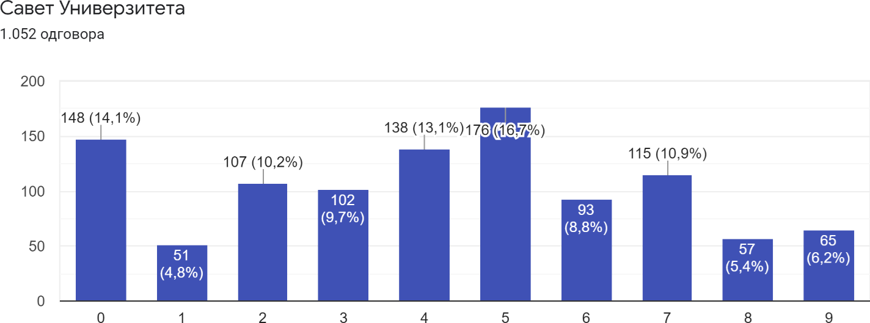

G) The distribution of the answers of the surveyed students to the question about trust in the work of the university senate is almost identical to the distribution of the answers about the trust in the work of the university council (Graph 29g).

Chart 29

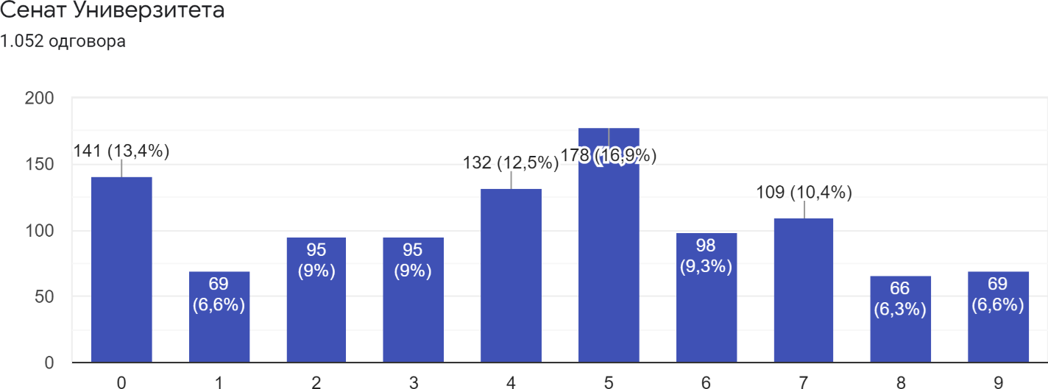

D) About trust in the work of the university ombudsman (Chart 29d):
  - 37.9% of the surveyed students expressed a negative sentiment, while 14% of the respondents stated that they have no confidence in the work of the university ombudsman;
  - 31.3% of respondents declared that they partially trust the work of this university body;
  - 30.8% of respondents declared that they had a lot of trust or complete trust in the work of the university ombudsman, while 5.2% of respondents have complete trust to his work.

Chart 29d

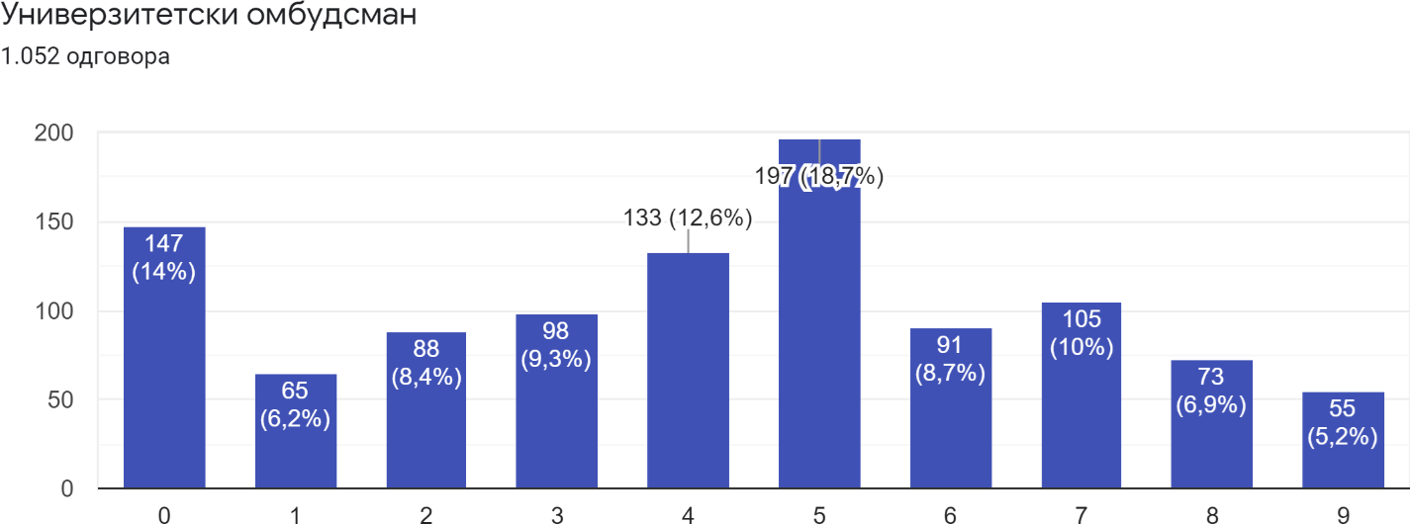

E) Regarding the activities of the dean of their respective faculty, the surveyed students stated the following (Graph 29e):
  - 37.2% of the respondents have no or little confidence in the activities of the deans of their respective faculties regarding combating corruption at the faculty, while 14.8% of the total respondents have no confidence whatsoever in their activities related to combating corruption at the faculty;
  - 28.1% of respondents have partial, i.e. moderate trust in the dean's activities;
  - 34.7% of respondents have a lot of trust or complete trust in the dean's work to combat corruption at their respective faculties, with 7.7% of respondents declaring that they have complete trust in their work.
However, in these results, it is worth highlighting the ratio of those students who have no confidence in the work of the dean (14% of all respondents) to those who declared that they have full confidence in the work of the dean (7.7% of all respondents).

Graph 29e

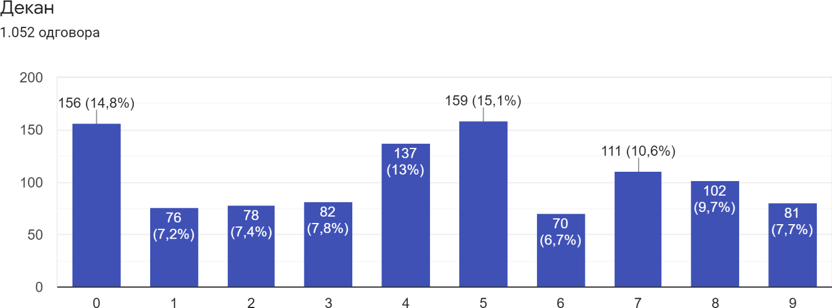

F) Regarding the activities of the faculty council (Graph 29f), the results were distributed as follows:
  - 40% of the respondents declared that they have no or very little trust in the activities of the faculty councils regarding the combating corruption at their respective faculties, while 14.6% of all respondents declared that they have no trust at all in the work of these bodies;
  - 28% of those surveyed declared that they have partial or moderate confidence in their activities to combat corruption;
  - 32% of those surveyed declared that they have a lot of trust or complete trust in the work of these authorities, while 5.5% of surveyed male and female students declared that they have complete trust in the work of these authorities.
In connection with the above results, there is an increase in total negative responses (40%) regarding trust in the work of the faculty council compared to negative responses regarding trust in the work of the dean (37.2%), with the percentage of responses denying any trust in the work of the aforementioned authorities being almost identical (14.8% of respondents have no confidence in the dean, compared to 14.6% of respondents who have no confidence in the work of the faculty council).

Chart 29f

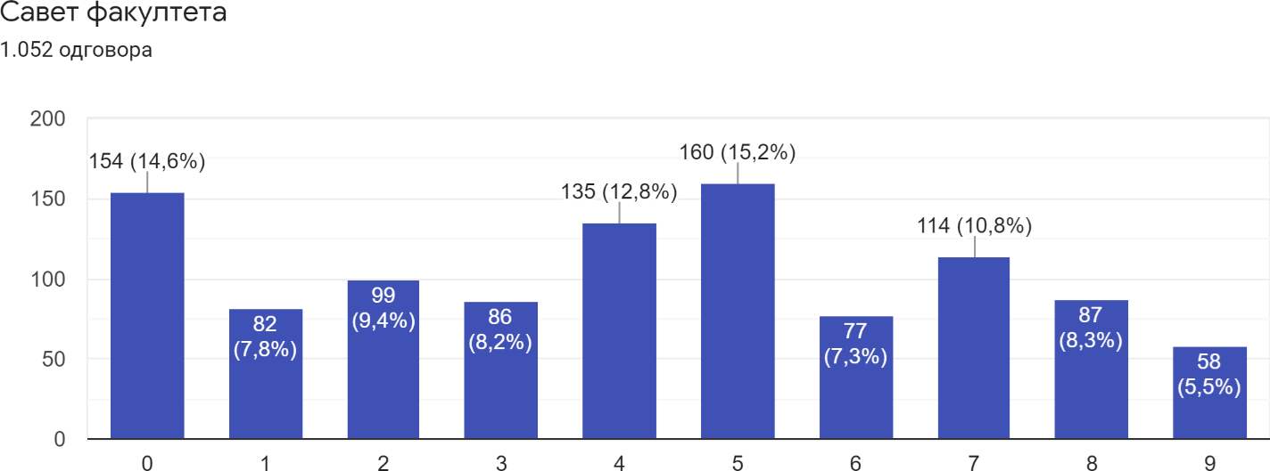

G) When it comes to the activities of academic councils in connection with combating corruption at their respective faculties, as to the trust in the work of those bodies, the results are distributed as follows (Graph 29g):
  - 40.4% of all respondents expressed a negative opinion, while 14.3% declared that they had no confidence in the work of those bodies;
  - 27% of the respondents declared that they have partial or moderate confidence in their work in connection with combating corruption;
  - 32.6% of respondents declared that they have a lot of trust or complete trust in the actions of these bodies, while 6% of respondents declared that they have complete trust.

Graph 29g

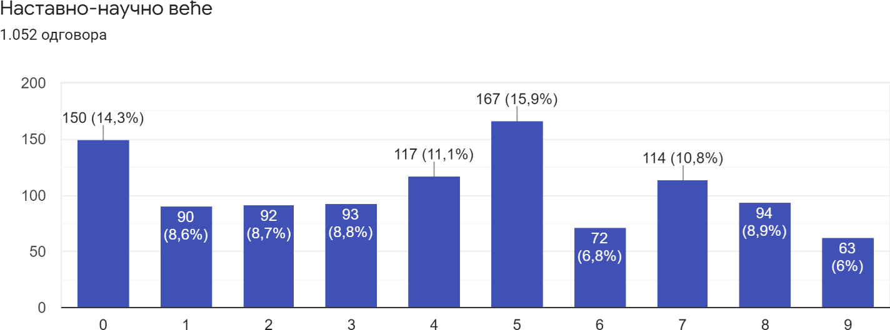

H) The activities of the teaching staff at the faculties in connection with combating corruption were graded as follows (Chart 29h):
  - 38.2% of the surveyed students have no or very little confidence in the activities of the teaching staff related to combating corruption at the faculties, while 12.2% have no confidence in their activities;
  - 25.8% of respondents have partial or moderate confidence in the activities of the teaching staff to combat corruption;
  - 36% of respondents have high or complete confidence in the activities of teaching staff in connection with combating corruption at faculties, whereby 6.9% of respondents have complete confidence in their work.

Graph 29h

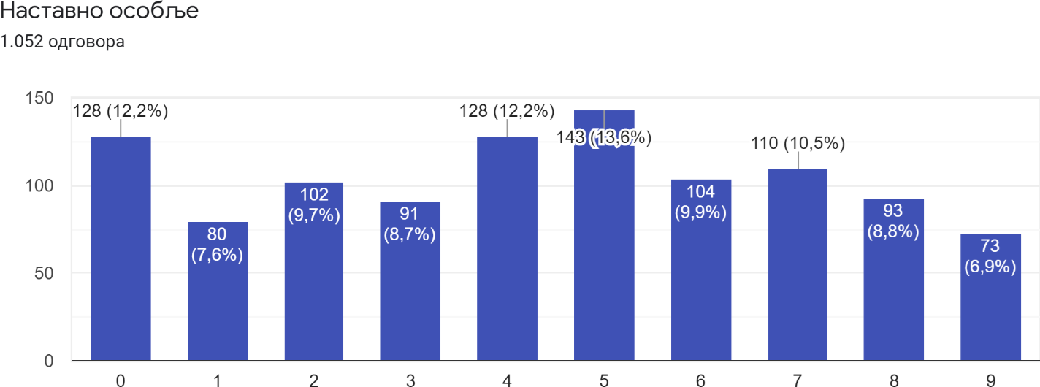

I) The trust of the surveyed students in the activities of the student services at their respective faculties, related to combating corruption, was allocated as follows (Graph 29i):
  - 47.4% of surveyed students (almost 1/2 of all respondents) have no or very little trust in the activities of student services, while every fifth respondent has no trust in the work of these services (19.7%);
  - 21.4% of respondents have partial or moderate trust in the work of these services;
  - 31.2% of respondents have high or complete confidence in the work of these services, while 6.9% of respondents have complete confidence in their work.
In the mentioned results, a significant difference is noticeable in the ratio of students who have no confidence at all in the work of these services (19.7% of all respondents, i.e. 1/5), and those who have full confidence in the work of the aforementioned services (6.9% of respondents), which is a ratio of almost 3:1 in favor of those who have no confidence in the work of faculty services.

Graph 29i

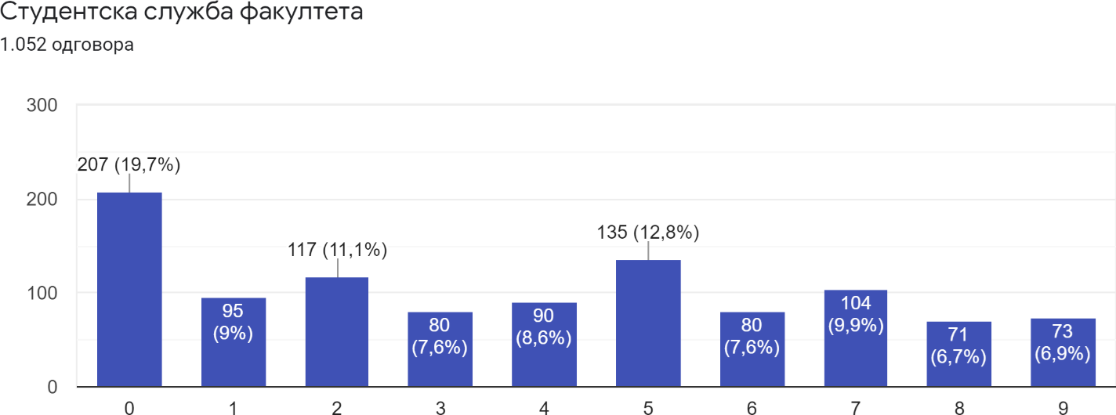

J) Special attention is drawn to the distribution of the answers of the surveyed male and female students to the question about their trust in the student parliaments at their respective studies. The distribution of responses was carried out as follows (Graph 29j):
  - As many as 56.9% of those surveyed declared that they have no or very little trust in the work of student parliaments, while as many as 30.3% of those surveyed answered that they have no trust whatsoever in the work of student parliaments;
  - 18.1% of those surveyed declared that they have partial or moderate confidence in the work of student parliaments;
  - 25% of respondents declared that they have high or complete trust in the work of student parliaments, while only 5.4% of respondents opted for the option of complete trust.
At this point, there is a significant difference in the number of respondents who have no confidence at all in the work of student parliaments (30.3%) compared to those who have full confidence in the work of student parliaments (5.4%). Their ratio is almost 6 to 1 in favor of those who have no confidence at all in the work of student parliaments.

Graph 29j

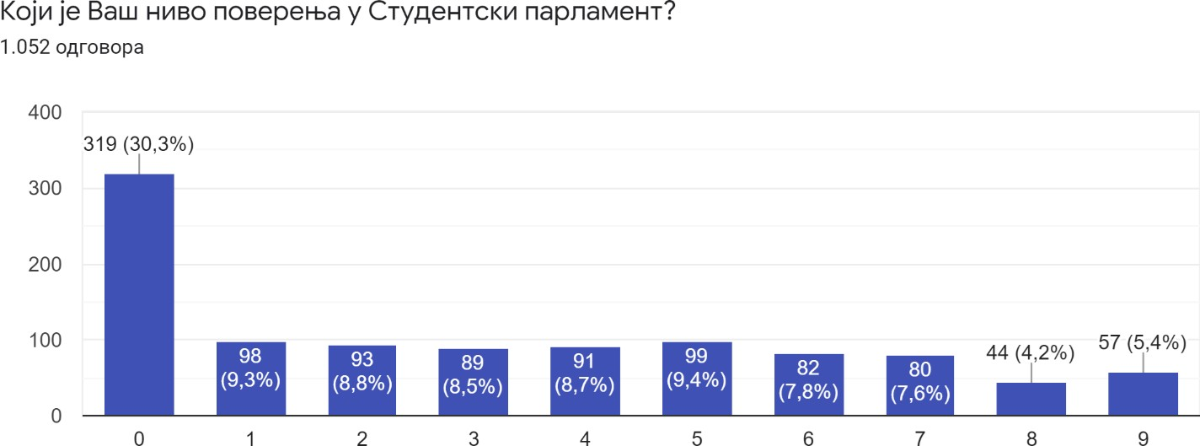

When it comes to the trust that certain bodies of the faculty, that is, the university, enjoy among students in terms of combating corruption, almost all bodies obtained approximately the same average rating. If we exclude the two worst rated bodies, this rating ranges from 4.14 to 4.35. The teaching staff (4.35) and deans (4.34) received the highest marks. The student parliament (3.16) and the student service of the faculty (3.84) have by far the worst rating.

Chart 29k

The degree of students' trust in the bodies of the faculty, that is, the university, in terms of addressing and combating corruption
005
4.35
4.34
4.29
4.24
4.22
4.19
4.19
4.19
4.14
3.84
3.16
005
004
004
003
003
002
002
001
001
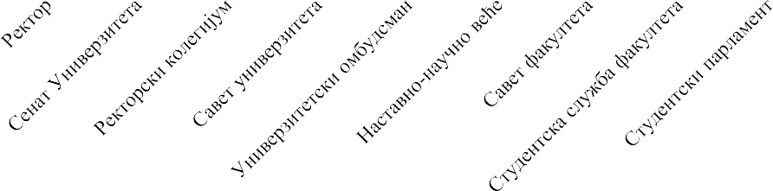
000

Comments on the survey
  - I think that most students do not know who to turn to if they learn about corrupt activities at the faculty due to insufficient awareness, which is a problem,.
  - I advise that the survey be later expanded to examine the possibility of discrimination that is not necessarily related to specific services or material gain of University employees, but to “informal” instances of political repression against students based on their free opinion.
  - Well done, it’s high time for the state to tackle this problem.
  - Thank you for allowing us to express our (mis)trust that we have had in the student parliament for years.
  - A topic that needs to be talked about more, owing to the research you have started.
  - I don't know what the exact goal of the survey is, but I think that corruption, especially at the university, should be dealt with in a more concrete way. Frankly it’s better than nothing. Greetings and all the best.
  - The solution to this would be very simple: for an offence, the professor should be fired and banned from participating in educational activities. Such things cannot be tolerated and there is no good enough excuse for them.
  - I would appreciate it if there was some body at the Faculty of Philosophy that could receive comments and complaints from students on individual courses and the system in general.
  - I think that the biggest problem is the corruption of institutions whose main mission is to suppress and regulate these types of problems not only at the university but in Serbia as a whole. I have the least confidence in you. Do your job better, or at least conscientiously.
  - I often pass by the Agency for the Prevention of Corruption in the city and I hope that now that I am aware of its work, I will be able to report any corrupt activities that I notice, not only at the university but also in other places/institutions
  - It would be good to include some questions related to the abuses of positions at faculties.
  - Appreciate your work on this topic. I think the survey is not specific enough and you will only get a general picture of the situation. Also a big problem, and insufficient attention is paid to it here, is copying and the use of illegal means (which are not bribes) for taking exams, for which illegal means there is no systemic solution and they are very widespread.
  - Interesting.
  - Although there is no corruption in my faculty, this is an absolutely necessary and excellent survey. STOP CORRUPTION!!!
  - I believe that this survey will help in combating corruption at the faculties of the University of Belgrade.
  - I hope the results will be published soon. 😊

  - A very good survey and an interesting topic that is rarely talked about. Although I believe that corruption will never be eradicated.
  - Instead of questioning students, which is necessary in any case, you should question much more important people in this society, because then maybe someone will gain trust in you as an institution, i.e. you will gain authority as someone who really deals with problems, and does not accept bribes/corruption :)
  - I am very satisfied with the survey, I hope it will achieve its purpose.
  - Deal with corruption at the faculties!
  - Thank you for the opportunity to express our dissatisfaction with the faculty authorities, primarily the student parliament.
  - Great topic, finally!
  - I would really appreciate if someone put an end to bribery, first of all because of the consequences that are manifested even after many years.
  - It is necessary to introduce anonymous passing of exams and have a new independent examination of all those who obtained a diploma of the Faculty of Medicine in the last 15 years by foreign professors. It is dangerous that the children of corrupt professors at the Faculty of Medicine in Belgrade, who did not even appear for the exams, are now working at the same faculty as assistants and lecturers.
  - Finally an important topic, I hope someone reads these answers.
  - I believe that this poll, like all the other polls in this country, is absolutely meaningless. This country and the system are built on corruption, if you report corruption to a superior, there is a high probability that this person is also involved in some form of corruption (therefore, they will not take any action). I will certainly always fill out a survey of this type and express my dissatisfaction.
  - This survey is a good idea, but since the exams and diplomas are bought by people who are rich and whose parents have a strong influence on the faculty or some faculty members, I don't believe it will actually change anything.
  - A colleague from the student parliament told me that one guy was offered 3000 euros not to run for student parliament, because he was visibly against the bribed majority of the parliament. I also heard that there is an audio recording of that conversation. 2) The President of the student parliament of the Faculty of Medicine, whom the students call Aca Tarapana (since he profits greatly from the organization of freshmen parties in the "Tarapana" night club), repeated his year in the 2020/2021 academic year and as such should not be a member of the student parliament. Instead, he is the president of it.
  - I hope that finally something like this will have a real purpose. Because we will one day be treated by people who buy exams. And we, who have a worse grade average because of those who buy exams, will be forgotten.
  - Corruption throughout the university is more than obvious. In Serbia, instead of knowledge, the university teaches education about corruption. When you study at a university like this, you wonder what is the value of your degree if it is obtained in such an invalid way. That diploma then becomes just a piece of paper, and people leave the university with the same knowledge they came with in the first place.
  - I hope that all this will not remain only at the level of a research. Although I am very skeptical about the future of higher education in our country, I want to believe that someone will finally start addressing this issue in a serious manner. People who participate in the aforementioned illicit acts (corruption, bribery) certainly do not have enough shame and self-awareness about the acts they commit. Therefore, I believe that the best solution would be to publicly present all known facts with previously thoroughly collected evidence, because for such people, the only way to re-educate them is public condemnation and punishment (a fine coupled with suspension from the faculty for a certain period of time). I saddens me that such examples, even if they are isolated ones, harm the reputation of the institution, which is something that many honorable and excellent doctors/professors fight for, just as diligent students who have achieved success with their own efforts and not nepotism or sexual favors.
  - No question was asked to explain why we did not report corruption: specifically at the Faculty of Medicine in Belgrade, you cannot find out how to protect student and other rights at the faculty, and there is no cooperation between the faculty and students. Specifically, there has been a desire to report various inappropriate situations, but since there seems to be no system of that type, and on the other hand, since the pressure of the environment as to how “professors will take revenge on us” is extremely persistent, my colleagues and I always follow the line of least resistance and keep a low profile to just try to graduate. This pressure comes from other students, but also from the faculty employees, both in teaching and in the administration, and very often it has the tone of well-intentioned advice. Thus, corruption, mythomania, sexual harassment and misconduct, discrimination and abuse of power of other kinds of misconduct remain undetected and keep happening, because when you turn a blind eye to one thing, you soon turn a blind eye to other things and eventually to everything. The Faculty of Medicine in Belgrade is on the brink.
  - Unfortunately, the Faculty of Medicine has a notorious reputation for massive corruption, which we students encounter directly or indirectly. A certain number of students pass the exams almost without any effort and in the end of the day they represent the faculty, which overall leads to a decline in the reputation and quality of teaching. I would suggest to the new dean, who is so far showing outstanding work results and who enjoys great respect from the students for his efforts and commitment to improving the quality of teaching and returning the faculty to its pedestal, to conduct an anonymous survey among students where we could all report known cases of bribery and of corruption and to form a committee of teachers and support staff and also a body consisting of students who would help in the fight against corruption (it is necessary that these students are not from the ranks of the student parliament, because the latters is a completely unethical organization, which does not enjoy the trust of so to speak better students) .
  - I hope that this survey and research will be the basis for raising the awareness of authorized persons with the aim of suppressing corruption at the Faculty of Medicine, which in some departments and with certain professors is definitely a mockery not only of the university but also of Serbia as a country. Props to all the wonderful, honest and moral professors of the Faculty of Medicine, which are certainly the majority, but this minority really spoils the reputation of an institution and this problem requires a solution.
  - Students are witnesses not only corruption in the teaching activities, but also in the daily, practical work of professors with people.

  - The Faculty of Medicine in Belgrade has been a hotbed of corruption (and many other things) since time immemorial. Changes must be radical and happen gradually. Discrimination and corruption are present on many levels, if you don't have a popular and distinguished surname, you will fall out very easily at one of the bends. Let alone getting a job afterwards, which is practically impossible. Everyone should look themselves in the mirror. Accordingly, let the people conducting this research first ask themselves if they have participated in any of the events covered by the survey, because I personally doubt that they have not (although I don't know who it is, I just relay on classic hypocrisy and the double standards that we encounter every day). If you really care about putting an end to such things, it is possible, but you have to be very brave and apply the rules to EVERYONE, without exception.
  - Corruption, and selling/buying exams at the Faculty of Medicine exists... it is public knowledge and nobody is doing anything about it.
  - DO SOMETHING ABOUT THIS ISSUE!!!!!
  - Of all the bodies of the faculty, I trust the student parliament the least because they are directly connected with other bodies and work only for their own benefit.
  - Thanks for your interest in this issue. In addition to money, it is important to pay attention to interpersonal relationships, where everything happens quietly because these people know each other outside of the faculty and are doing each other favors. Even when we notice such a case, we don't know who to turn to. And even if we knew who was responsible for this, we would be afraid that such person may be related to or friends with the people we want to complain against. In such a case everything would be swept under the rug and we would be crossing some important people. That should be addressed.
  - We are honored that at the Faculty of Medicine we have the opportunity to fill out this survey because there is a breeding ground for corruption and bribery that damages its reputation.
  - I am in doctoral studies and specialization, but I took the liberty of participating in your survey. I have to admit that I am sorry because I don't know which authorities a person encountering corruption can turn to. I sincerely hope that your research will have consequences for curbing widespread corruption. Big greetings and support for this project!!
  - If this survey contributes to at least a 5% increase in the awareness about the corruption of this faculty (and university), then it’s good.
  - Requiring students and health workers to be tested weekly at their own expense or to receive vaccines that are still under examination is a violation of the Constitution, and is something that is beyond the purview of the authority that prescribed the measures.
A total of 92 students from the observed faculties of the University of Belgrade commented on the survey.
Sixteen comments contain general remarks and clarifications of the answers given by the respondents in the survey.
Nineteen comments contain recommendations for improving the work of the Agency and improving the questionnaire itself in future research.

Twenty-one comments said that the survey was futile, meaningless and disbelief was expressed as to its success.
In nine comments, the survey was rated poorly, and in four comments, the Agency's work was rated extremely unfavorably.
The research conducted by the Agency was favorably evaluated in 27 comments.

CONCLUSION

In this research, a total of 1052 male and female students from six faculties of the University of Belgrade were surveyed.
A total of 86.7% of surveyed students were born in the period 1997 - 2001, which corresponds to the age of full-time studies from the second to the fifth year of study (that is, up to the fourth year of study and graduation eligibility period). Students in the second, third and fourth year of study make up over 4/5 (four fifths), while with students in the fifth year of study, that percentage is 91.8% of those surveyed.
The number of female students compared to the number of students who filled out the questionnaire is in an approximate ratio of 2:1, which on the one hand may indicate a greater number of women among higher education youth, but on the other hand it may also indicate a greater interest of female students in answering the questions asked.
Although the number of budget-financed (34,643) and self-financing (37,814) students at the University of Belgrade is almost equal, the number of respondents who are financed from the budget compared to the number of self-financing students stands in an approximate ratio of 3:1, which may indicate the different degree of interest of budget and self-financing students in the phenomenon of corruption at the University, that is, a the greater interest of budget-financed students in that phenomenon.
The fact that almost 1/4 (one quarter) of the surveyed students did not wish to answer the question about the total average monthly income of the households they come from, on one hand can indicate either extremely high or extremely low average monthly income of their respective households and on the other hand, it may be a consequence of students' belief that such data is a deeply personal matter, and that it should not be disclosed.

Research results
In the process of analyzing the collected data, the following groups of data were determined:

- Data on the perception of the presence of corruption and discrimination at the faculties, i.e. the university
Based on the results obtained with regard to the question of the perception of corruption at the faculties of their studies, the fact that only 14.2% of the sample believes that there is no corruption at these faculties at all, while as many as 85.8% of the respondents expressed the opinion that corruption at the observed faculties exists to different extents of prevalence and in different intensities, whereby the claim that corruption is extremely pronounced was made by 12.8% of those surveyed.
The situation is different when it comes to the perception of corruption at the university as a whole. Attention is drawn to the fact that only 3.3% of the sample believe that there is no corruption at the university at all, while as many as 96.7% of the surveyed students expressed the opinion that corruption at the university is present in different scope and intensity, while the assertion that corruption extremely pronounced was expressed by almost every fifth respondent.
A significant difference in the responses regarding the perception of the degree of corruption at the respective faculties of the surveyed persons, i.e. at the university as a whole

could be explained by the reticence of the respondents to explicitly state the existence of corruption at their respective faculty, while such reticence does not exist for a large percentage to state a clear position on the presence of corruption at the university. This conclusion is based on the fact that the percentage of respondents who completely deny the existence of corruption at the faculties of their studies (14.2%, i.e. 149 answers) is significantly higher than the percentage of respondents who deny the existence of corruption at the university (only 3.3%, i.e. 35 surveyed students).
When it comes to the perception of discrimination at their respective faculties, according to the data obtained, the majority of surveyed students believe that discrimination when taking exams is widespread at their faculties.
By analyzing the answers to the question “If the answer to the previous question is 'Yes', describe on what grounds discrimination is carried out?” 13 groups of grounds for discrimination during exams were defined, with the following ones prevailing:
  - gender and sexual orientation;
  - origin (belonging to an influential family) / social influence and power / social status, financial status;
  - nepotism; cronyism; acquaintance with the examiner;
  - bribery; a "deal" with the professor; regular private consultations; while the other grounds are listed as follows:
  - nationality; religion; race;
  - personal preference and discretion of examiner;
  - grade point average and duration of studies;
  - physical appearance and attire;
  - political opinions; political connections; partisan affiliation (whereby two respondents mentioned affiliation with the ruling party as a basis for positive discrimination);
  - native origin (Belgrade natives are positively discriminated);
  - membership in the student parliament (positive discrimination);
  - the grounds of (non)vaccination;
  - (a curiosity: two respondents cited “rooting for the same football club as the examiner” as grounds for positive discrimination of students).

- Respondents’ personal experiences with corruption
The ratio of respondents who denied that a third person had once suggested to them to “broker” giving someone a bribe in order to take an exam, obtain a diploma or achieve some other benefits related to studying, compared to those who confirmed it or did not wish to answer the question was almost 4 to 1, that is, 78.7% to 21.3% (14.2% answered “yes” and 7.1% chose the option “I do not wish to answer”).
The imbalance is more pronounced in the answers to the question of whether during their studies a faculty employee (teaching or non-teaching staff) had ever demanded bribes from them, where 87.9% of the sample answered that they had not experienced that personally, only 7.8% (82 respondents) indicated that they had encountered such an employee, while 4.3% chose the option “I do not wish to answer.”
Among the respondents who confirmed that a staff at the university had demanded a bribe from them (82 respondents), 69 answered the question as to what type of bribe was demanded, of which 75% answered that they were asked for money, 13.2% said they were asked to make a gift; 11.8% said they were required to provide service as a form of bribery.
As for the personal involvement of the students in corruption at the university by offering bribes to faculty staff, only 1% of respondents admitted that they had offered bribes to employees at the university in order to obtain some benefits related to their studies, while 2.8% of respondents did not want to say anything about personal involvement in such form of corruption.
When asked if they had bribed a staff of the university during their studies, 2% of the respondents confirmed that they had bribed staff at the university, while 1.6% of the respondents chose the option “I do not wish to answer.”
The situation with the answers about bribery is somewhat different when it comes to the question of whether the respondents have heard of someone who has passed an exam, obtained a diploma or achieved benefits by the means of bribery at any faculty of the University of Belgrade. This question was answered by everyone in the sample (1052 responses), whereby more than 3/4 (three quarters) stated that they had heard of a student who, by the means of bribery, has passed an exam, obtained a diploma or achieved some other benefit during their studies at the university, and 2.3% of the total number of respondents chose the option “I do not wish to answer.”
Also interesting are the results related to the question of whether they personally know a student who has passed an exam at a faculty of the University of Belgrade in some other illegal way - by copying, using earpieces, by having another person take the exam for them, etc. - 83.5% of the sample stated that they know such persons, and 2.4% of the respondents did not wish to answer that question.
Among the students who provided an answer to the question of what kind of service/convenience they had given a bribe for, if they did bribe an employee at the faculty during their studies, almost half (47.8%) did not wish to answer what kind of convenience or service it was, and 30,4% answered that they resorted to bribery to pass the exam.
When asked if they know that a diploma can be purchased at their university - all 1052 respondents answered - 14.9% stated that they have heard of it, while 8.2% did not wish to answer the question.
The structure of the answer to the question whether they know of any such case is generally in line with that of the previous answers.

- Answers related to the reaction of the respondents to corruption
From the perspective of combating corruption, the answers of the surveyed students to the questions concerning their reaction to corrupt behavior at their faculties are very inspiring, namely: if they have already reported corruption at their faculty/university, what experiences have they had in connection with reporting corruption, and whether they would report corruption at their faculty/university in the future.

All members of the sample responded to the question as to whether they had already reported corrupt behavior at their faculty or university, as follows:
  - 95.6% (1006) of those surveyed answered that they had never reported corruption at the faculty or university;
  - 3.6% of respondents did not wish to answer the question;
  - Only 0.8% of the sample (nine respondents) answered that they have reported corruption at the college or university.
Respondents who have reported corruption indicated to whom they reported corrupt behavior. The following answers are of particular interest:
  - “To certain professors, but it was not accepted.”
  - “I don't even know who it could be reported to.”
  - “I went to the rectorate, wrote emails to the university several times and everything was covered up.”
One answer is particularly significant because it clearly indicates the insufficient awareness of students as to who they can report corruption at the faculty to (“The answer is no, but I have a question for you - who exactly should we report such situations to? These people are judge, jury and executioner!”).
To the question “If you have already reported corrupt behavior at your faculty or university, what is the outcome of the report?” 43 answers were given. Of that number: 55.8% answered that they did not know the outcome of the procedure; 23.3% did not wish to answer the question; 18.6% answered that the procedure has not been initiated. Only 2.3% (1 respondent) answered that the procedure was completed.
Forty-nine answers were given to the question of whether students as “whistleblowers” had suffered consequences after reporting corrupt activities at their faculty or university; 44.9% of those who answered chose the option “I do not wish to answer the question”; 38.8% of the 49 answered that it had no consequences; 16.3% of the 49 answered that they had suffered consequences, and the following answers were given as to the form of pressure:
  - “I had a problem with passing a certain exam that followed the my complaint”;
  - “Unfair behavior of the mentioned professors and psychological torture that is difficult to recount, but certainly not exercised by those people for the first time”;
  - Mental bullying;
  - Threats.
The distribution of responses to the question as to whether students would report corrupt behavior at their faculty in the future was as follows: 55.7% of the sample indicated that they would report future corrupt behavior; 23.2% stated that they would not report such behavior in the future either, and 21.1% chose the option “I do not wish to answer the question.”
To the question to whom they would submit a report on corrupt behavior if they decided to take such a step, an answer was provided by 620 students, i.e. 58.94% of the entire sample, whereby:

  - 56.3% (349 answers) of those who answered (33.18% of the entire sample) said that they would submit the report to the Agency for the Prevention of Corruption, which speaks to the trust that the Agency enjoys among the respondents.
On the other hand, data obtained from the answers to the question which authority at the faculty of their studies is responsible for handling corruption reports, with the possibility of giving multiple answers at the same time, is not encouraging, whereby 76.1% of the sample (801 answers) answered that they do not know.
As for the methods that should be used to combat corruption at the faculties, i.e. the University, with the possibility of providing several options at the same time, the answers were distributed as follows:
  - 61.1% (643 responses) of the total respondents want the citizens to be better informed on specific cases of corruption;
  - 60.7% (639 responses) want stricter application of prescribed sanctions;
  - 51.2% (539 responses) are in favor of raising awareness about the harm of corruption;
  - 40.7% (428 responses) are in favor of imposing stricter sanctions;
  - 6.7% (70 responses) did not know which method they could resort to.
Based on the above answers, it can be concluded that almost 61% of the respondents think that the prescribed sanctions are adequate, but that the problem is that the application of the existing regulations is lacking.
On the other hand, 61.1% of the surveyed students plead for providing more information to the public about specific cases of corruption, while half of them demand the raising of awareness about the harmfulness of corruption, which may indicate that so far there have been no substantial activities related to educating citizens about the harmfulness of corruption.

- Perception of the role of the University and the respondents’ respective faculties in dealing with and combating corruption
This group of answers includes the answers to the questions about the awareness of male and female students about the existence of a code of conduct at their respective faculties, and about the awareness of the content of such documents, as well as a set of questions related to the degree of trust of students in the work of the bodies of their respective faculties, i.e. the bodies of the University in relation to the prevention of corruption and mechanisms for combating it.
Regarding the familiarity of students about the existence of a code of conduct, a code of ethics or a similar act that regulates the rules of behavior of teachers and students of the faculty in delivering the curriculum and in the process of grading the students:
  - 61.1% of surveyed male and female students (almost 2/3 of the sample) are aware that there is such a code/act at the faculty of their studies.
A total of 668 respondents (63.5%, i.e. almost 2/3 of the total sample) answered about the familiarity of the surveyed students with the content of the code of ethics or another similar act that governs the rules of conduct of teachers and students of the faculty in delivering the curriculum and in the process of grading the students. 55.7% of male and female students who answered stated that they were familiar with the content of such an act (35.4% of the total sample).
The fact of the existence of ethical codes at faculties and the attitude of the surveyed students towards ethical codes should be highlighted as positive, considering that a significant number of the students are aware about ethical codes and their content.
Data on the degree of trust of the surveyed students in the authorities of the university, i.e. the authorities of the faculties of their studies, based on the following question: “What is the degree of trust in the authorities of your faculty, that is, the university in terms of dealing with and combating corruption?” was provided by all 1052 respondents. The respondents rated their trust in the authorities of the university, i.e. their respective faculty, with grades from 0 to 9, and their answers were distributed as follows:
A) Answers of surveyed students about trust in the rector can be grouped into three groups of answers (first group: no or very little trust - grades 0 to 3; second group: partial or moderate trust - grades 4 and 5; third group: high degree of or complete trust - grades 6 to 9), and the percentages are the following:
  - 13.1% of respondents answered that they have no confidence at all in the rector's activities to combat corruption at the university;
  - the next 6.2% of respondents rated their trust in the rector with the grade 1 - their trust in the rector’s actions in relation to combating corruption at the university is minimal;
  - 7.9% of the respondents rated their trust in the actions of the rector of the university in combating corruption at the university with the grade 2;
  - 9.5% of the surveyed students rated the activities of the rector of the university in combating corruption at the with the grade 3.
Therefore, a total of 36.7% of those surveyed declared that they have no or very little trust in the actions of the university rector in the matter of combating corruption at the university.
31.4% of those surveyed have partial or moderate confidence in the actions of the rector in connection with combating corruption at the university.
A total of 31.9% of those surveyed have a lot of trust or complete trust in the rector's work to combat corruption at the university, with 7% of the respondents stating that they have complete trust in the rector's actions.
The ratio of the three groups of answers is divided into almost 1/3 of the respondents each, with the percentage of respondents who have no confidence at all or have little confidence in the rector's activities prevailing by about 5% compared to the other two groups.
However, the ratio of respondents who have no confidence at all (13.1%) to the respondents who have full confidence (7%) was noted.
B) Answers of the surveyed students about trust in the rector's collegium are distributed in approximately similar percentages relative to the answers related to trust in the rector of the university, which is understandable given the fact that the rector's collegium is managed by the rector of the university himself.
C) The activities of the university council were evaluated as follows:
  - 38.8% of the respondents stated that they have no or little confidence in the activities of the university council to combat corruption at the university, while 14.1% of the respondents have no confidence in the work of the university council;

  - 29.8% of those surveyed declared that they have partial or moderate confidence in the work of this body;
  - 31.4% of respondents declared that they have a lot of trust or complete trust in the work of the said body, while 6.2% of respondents declared that they have complete trust in the work of the university council.
According to the mentioned results, there is an increase in the number of students who expressed a negative opinion as to their confidence in the activities of the university council, in relation to the number of students who have negatively evaluated the activities of the rector, that is, the rector's collegium.
D) The distribution of the answers of the surveyed students to the question about trust in the work of the university senate is almost identical to the distribution of the answers about the trust in the work of the university council.
E) On trust in the work of the university ombudsman:
  - 37.9% of the surveyed students expressed a negative opinion, while 14% of the surveyed students have no confidence at all in the work of the university ombudsman;
  - 31.3% of respondents declared that they partially trust the work of this university body;
  - 30.8% of respondents declared that they had a lot of trust or complete trust in the work of the university ombudsman, while 5.2% of respondents have complete trust to his work.
F) Regarding the activities of the deans of their respective faculties, the surveyed students expressed their views as follows:
  - 37.2% of the respondents expressed a negative opinion about the trust in the activities of the deans of their respective faculties of studies in connection with combating corruption, while 14% of the respondents have no confidence whatsoever in their activities to combat corruption;
  - 28.1% of those surveyed stated that they have partial or moderate trust in the dean's activities;
  - 34.7% of respondents have a lot of trust or complete trust in the dean's work to combat corruption at their respective faculties, with 7.7% of respondents declaring that they have complete trust in their work.
Regarding the above results, attention is drawn to the ratio of those students who have no confidence at all in the work of the dean to students who declared that they have complete confidence in the work of the dean.
G) Regarding the activities of the faculty council, the results are as follows:
  - 40% of respondents expressed a negative or mostly negative opinion as to their confidence in the activities of faculty councils regarding combating corruption at their respective faculties, while 14.6% of all respondents stated that they had no confidence in the work of these bodies;
  - almost 1/3 (one third) of those surveyed have a lot of trust or complete trust in the work of these authorities, while only 5.5% of the respondents have complete trust in the work of these authorities.
There is a slight increase in the total number of negative responses about confidence in the work of the faculty council compared to negative responses about confidence in the work of the dean, whereby the percentage of responses denying any confidence in the work of the aforementioned authorities is almost identical.
H) When it comes to the activities of academic councils in connection with combating corruption at their respective faculties, as to the trust in the work of those bodies:
  - 40.4% of all respondents stated negative or mostly negative opinions, while 14.3% of respondents had no confidence in the work of those bodies;
  - 32.6% of respondents declared that they have a lot of trust or complete trust in the actions of these bodies, with 6% declaring that they have complete trust.
I) The activities of the teaching staff at the faculties in combating corruption were evaluated as follows:
  - 38.2% of the surveyed students have no or very little confidence in the activities of the teaching staff related to combating corruption at the faculties, while 12.2% have no confidence in their activities;
  - 36% of respondents have high or complete confidence in the activities of teaching staff in connection with combating corruption at faculties, whereby 6.9% of respondents have complete confidence in their work.
J) The trust that the surveyed students showed in the activities of the student services at their respective faculties, related to combating corruption, was allocated as follows:
  - 47.4% of surveyed students (almost 1/2 of the sample) answered negatively about their trust in the activities of student services, where every fifth respondent has no trust at all in the work of these services (19.7%);
  - 31.2% of respondents have high or complete confidence in the work of these services, while 6.9% of respondents have complete confidence in their work.
There is a significant gap in the ratio of students who have no confidence at all in the work of these services and those who have complete confidence in the work of the aforementioned services, which is a ratio of almost 3:1 in favor of those who have no confidence at all in the work of faculty services.
K) Attention is drawn to the distribution of the answers of surveyed students to the question about trust in the student parliaments at the faculties of their studies:
  - As many as 56.9% of those surveyed declared that they have no or very little trust in the work of student parliaments, while as many as 30.3% of those surveyed answered that they have no trust whatsoever in the work of student parliaments;
  - 25% of respondents have high or complete confidence in the work of student parliaments, while only 5.4% of respondents have complete confidence.
There is a significant gap in the number of respondents who have no confidence at all in the work of student parliaments compared to those who have full confidence in the work of student parliaments. Their ratio is almost 6 to 1 in favor of those who have no confidence at all in the work of student parliaments.
The research itself was commented on by a total of 92 students of the observed faculties of the University of Belgrade (8.8% of the sample). Sixteen comments contain general notes and clarifications of the answers given by the respondents in the survey; 19 comments contain recommendations for improving the work of the Agency and improving the questionnaires in future research; 21 comments found that the survey as futile and pointless, or expressed disbelief in the success of the survey. In nine comments, the survey was rated poorly, and in four comments, the Agency's work was rated extremely unfavorably. The research conducted by the Agency was favorably evaluated in 27 comments.

&

The obtained results of the conducted research indicate that the determination of the Agency for the Prevention of Corruption to conduct the research was fully justified. The results of the research showed that the aim of the research - to determine the degree of familiarity of students of the University of Belgrade with the phenomenon of corruption in general, the degree and scope of their perception of the existence of corruption at the university and specific observations of students about possible directions and aspects of permanent action to prevent corruption in higher education – has been fully achieved.
The quantity and quality of the obtained results indicate the significant interest of the students of the University of Belgrade in the phenomenon of corruption and its manifestations at the university, as well as in the ways and methods of opposing this negative phenomenon.
What does the research data show? Is there any reason for concern when it comes to corruption at the university?
When it comes to data on the perception of the presence of corruption and discrimination at the faculties, i.e. the university:
  - as many as 85.8% of the surveyed students expressed the opinion that corruption at the faculties of their respective studies exists in different extents and with different intensity, with 12.8% of the surveyed students saying that corruption is extremely pronounced;
  - only 3.3% of those surveyed believe that there is no corruption at the university at all, while as many as 96.7% of those surveyed are of the opinion that corruption at the university is expressed in different scopes and with different intensity, while 19.7% of those surveyed are of the opinion that corruption is extremely pronounced;
  - a significant difference in the answers about the perception of corruption at the faculties of study of the surveyed persons, that is, about the perception of corruption at the university as a whole, can be explained by the reluctance of the respondents to explicitly declare the presence of corruption at their faculty, while such reticence does not exist to state in a large percentage a clear position about the high presence of corruption at the university as a whole. This conclusion is based on the fact that the percentage of respondents who completely deny the existence of corruption at the faculties of their studies is significantly higher than the percentage of respondents who deny the existence of corruption at the university;
  - regarding the perception of discrimination at their respective faculties, according to the obtained data, it can be concluded that the majority of surveyed students believe that discrimination at their respective faculties when taking exams is widespread (44% of the sample). At the same time, based on the answers about specific cases of corruption, 13 groups of grounds for discrimination in taking the exam were determined, among which the following prevail:
- gender and sexual orientation;

- origin, social influence, social and financial status;
- nepotism; cronyism; acquaintance with the examiner;
- bribery, a “deal” with the professor; regular private consultations.
The analysis of the answers related to the personal experiences of the respondents with corruption yielded the following results:
  - 78.7% of the sample stated that they had never been suggested by a third party to broker offering a bribe to someone in order to take an exam, obtain a diploma or achieve other benefits related to studying, 14.2% answered that they had such an experience, and 7.1% chose the option “I do not wish to answer”;
  - the imbalance is even more pronounced among the respondents who answered the question of whether during their studies any of the faculty employees (teaching or non-teaching staff) asked them for a bribe, where 87.9% of the respondents stated that they personally had no such experience, only 7 .8% (82 respondents) indicated that they had the opportunity to meet such employees, who in most cases asked them for money, while 4.3% chose the option “I do not wish to answer”;
  - only 1% of respondents answered that they offered bribes to faculty employees in order to obtain some benefits related to their studies, and 2.8% of respondents chose the option “I do not wish to answer”;
  - 2% of respondents confirmed personal bribery of faculty employees, and 1.6% of respondents chose the option “I do not wish to answer”;
  - 76.4% (over 3/4) of the sample have heard of a student at any faculty of the university who, resorting to bribery, has passed an exam, obtained a diploma or some benefits during their studies, and 2.3% of the respondents chose the option “I don't wish to answer the question.” This data is opposed to the result of 96.4% of the sample who stated that during their studies they did not bribe any of the staff at the faculty, which may indicate either the fact that the respondents did not give an accurate answer regarding their possible involvement in corrupt activities at the faculty or to the fact that the information they have about “some student” who was involved in corrupt activities at any faculty of the University of Belgrade is unreliable and exaggerated;
  - 83.5% of the sample personally know a student who has passed an exam at a faculty of the University of Belgrade in some other illegal way - by copying, using earpieces, by having another person take the exam for them, etc., and 2 .5% of respondents chose "I do not wish to answer the question";
  - 76.9% of the sample have no knowledge that a diploma can be purchased at their university; 14.9% have such knowledge; 8.2% choose “I do not wish to answer”;
  - to the question of whether they know of a case of purchasing a diploma, a total of 218 answers were given, of which 22% were positive answers, while 17.9% chose the option “I do not wish to answer the question.”
When analyzing the data related to the reaction of the respondents to corruption, the following results were obtained:

  - only 0.8% (9 respondents) had already reported corruption at the faculty or university;
  - among the students who have previously reported corruption at the faculty or university, only 2.3% (1 respondent) stated that the procedure on their complaint was completed;
  - regarding the consequences after reporting corrupt activities at their faculty or university, 44.9% of “whistleblowers” chose the option “I do not wish to answer the question”, while 16.3% of them 49 answered that they have suffered consequences;
  - 55.7% of the sample members would report future corrupt behaviors; 23.2% would not report such behavior in the future either; 21.1% chose the option “I do not wish to answer the question.” Such a distribution of answers indicates the possibility that in the group of those not wishing to answer the question (over 1/5 of the given answers) there are also students who would report corrupt behavior, but for some reason do not want to explicitly declare it. Considering the above, it can be assumed that the percentage of students who would report corruption is higher than the one obtained;
  - 620 male/female students (58.94% of the sample) answered to whom they would submit a complaint for corruption in the future; of that number, 56.3% (349 responses) would submit a complaint with the Agency for the Prevention of Corruption (33.18% of the sample);
  - 76.1% of the sample (801 answers) do not know which authority at the faculty of their studies is responsible for handling corruption complaints;
  - In relation to the methods that should be used to combat corruption at the faculties and the University, 61.1% of the sample (643 responses) advocated for greater public information on specific cases of corruption; 60.7% (639 responses) advocated for stricter application of prescribed sanctions; 51.2% (539 responses) were in favor of raising awareness about the harmfulness of corruption.
Data on the perception of the role of the university and respective faculties in addressing and combating corruption:
  - almost 2/3 of the sample are aware that there is a code of ethics/some other code of conduct at the faculty of their studies, while 1/3 of the sample do not know about the existence of such an act;
  - 55.7% of male and female students who are aware of the existence of the code of ethics declared that they are aware of the content of such an act (35.37% of the sample);
  - 13.1% of the sample have no confidence at all in the rector's activities to combat corruption at the university, while a total of 36.7% of the sample have no or very little confidence in his activities (grades 1-3);
  - 38.3% of the sample have no or very little confidence in the actions of the rectors' collegium, while 12.7% of the sample have no confidence in the actions of the rectors' collegium at all. These results show a slight increase in the number of students who have little or no confidence in the work of the rector's collegium, compared to the surveyed students who expressed their confidence in the work of the rector himself;
  - 38.8% of respondents have no or little confidence in the activities of the university council to combat corruption at the university, while 14.1% of those surveyed have no confidence in the work of the university council; almost identical results refer to trust in the senate of the university;
  - 37.9% of the sample have no or little trust in the work of the university ombudsman, while 14% of those surveyed have no trust at all in the work of the university ombudsman;
  - 37.2% of the respondents expressed a negative opinion about the trust in the activities of the dean of their respective faculty in connection with combating corruption, while 14.8% have no confidence whatsoever in their activities to combat corruption;
  - 40% of the respondents expressed a negative or mostly negative opinion about their trust in the activities of the faculty councils regarding combating corruption at their respective faculties, whereby 14.6% have no trust at all in the work of these bodies;
  - 40.4% of all respondents said they have negative or mostly negative opinions about the activities of academic councils to combat corruption, while 14.3% of respondents had no confidence in the work of those bodies;
  - 38.2% of the surveyed students have no or very little confidence in the activities of the teaching staff related to combating corruption at the faculties, while 12.2% have no confidence in their activities;
  - 47.4% of respondents (almost 1/2 of the sample) assessed their trust in the activities of student services as negative or mostly negative, while every fifth respondent have no trust in the work of these services (19.7%);
  - As many as 56.9% of those surveyed have no or very little trust in the work of student parliaments, while as many as 30.3% have no trust whatsoever in the work of student parliaments.

Therefore, the following can be concluded:
- the surveyed students of the observed faculties of the University of Belgrade are aware of the harmfulness of the phenomenon of corruption, both for the public interest of society as a whole and for their own personal interests;
- the overwhelming number of surveyed students expressed the opinion that corruption, both in the faculties of their studies, and in the entire university, exists and is widespread in different scopes and in different forms;
- the majority of surveyed students believe that discrimination during exams is widespread at their respective faculties and they stated different grounds of discrimination;
- the overwhelming majority of those surveyed have never personally been involved in corrupt activities at the university in any way, and over 3/4 of those surveyed have no knowledge that a diploma can be purchased at their faculty. However, more than 3/4 of the sample heard of a student at any faculty of the university who, by resorting to a bribe, has passed an exam, obtained a diploma, or obtained some benefit while studying, while 83.5% of the sample personally knows a student who has passed an exam at a faculty of the University of Belgrade in some other illegal way - copying, using earpieces, by having another person take the exam for them, etc.;

- only 0.8% of the sample (9 respondents) had already reported corruption at the faculty or university, and only one respondent stated that the procedure on his report had been completed;
- 55.7% of the sample students explicitly stated that they would report future corrupt behavior, while an additional 1/5 of the respondents did not wish to explicitly answer that question;
- 620 male/female students (58.94% of the sample) answered to whom they would file a report for corruption in the future; of that number, 56.3% would submit a complaint with the Agency for the Prevention of Corruption (33.18% of the sample);
- 76.1% of the entire sample does not know which authority at the faculty of their studies is responsible for handling corruption reports;
- in order to prevent corruption, the majority of those surveyed are in favor of greater public information on concrete cases of corruption; for stricter application of prescribed sanctions; and for raising awareness about the harmfulness of corruption;
- almost 2/3 of those surveyed are aware of the existence of the code of ethics at their faculties and the majority are aware of the content of such codes;
- slightly less than 1/3 of those surveyed have confidence in the actions of the rector, the rectors' collegium, the council and the senate of the university in connection with the prevention of corruption at the university, while only about 31% of the respondents have confidence in the actions of the university ombudsman to prevent corruption at the university;
- only about 1/3 of those surveyed have confidence in the activities of the dean, the council, academic council, teaching staff and employees in the technical services of their faculties to prevent corruption; only 1/4 of those surveyed have confidence in the activities of student parliaments to prevent corruption.

Recommendations:

  - intensifying the activities of both the Agency and all other bodies in the legal system of the Republic of Serbia, responsible for the combating corruption, on additional education of students of the University of Belgrade to recognize corruption and its manifestations;
  - intensifying activities on providing additional education of students of the university in order to be able to recognize and oppose different forms of discrimination;
  - intensifying activities on providing additional to students of the university regarding the possibilities of reporting corrupt activities at the university and the authorities and bodies at the university and outside of it responsible for handling corruption reports by students;
  - making additional efforts for legal and institutional provision of effective mechanisms for addressing of corrupt behavior at the university;
  - making additional efforts in legal and institutional provision of effective mechanisms for the protection of student "whistleblowers.”

